**The British College** **KATHMANDU**

**Coursework Submission Coversheet**(individual coursework only)

**Faculty of Arts, Environment and Technology LBU Student Id:**

C7227267

**For checking by the student:**

Award name: Bsc Hons in Computing

Module code: 15781

Module name: Advance Database System (ADS)

Module run: 2021

Coursework title: Data warehouse Design and Development

Due Date: 2021/11/22

Module leader: (In LBU): Jackie Campbell, Sanela Lazarevski

Module tutor: (In TBC): Dibya Tara Shakya

**TURNITIN** Checked: YES **NO** ***(please circle)***

Submission date& time: Date: 2021/11/22 Time: Before noon

**Total Word Count: 8075 Total Number of Pages (including this front sheet): 69**

**In submitting this form with your assignment, you make the following declaration:**  
I declare, that the coursework submitted is my own work and has not (either in whole or part) been submitted towards the award of any other qualification either at LBU or elsewhere. I have fully attributed/referenced all sources of information used during the completion of my assignment, and I am aware that failure to do so constitutes an assessment offence.

Signed: 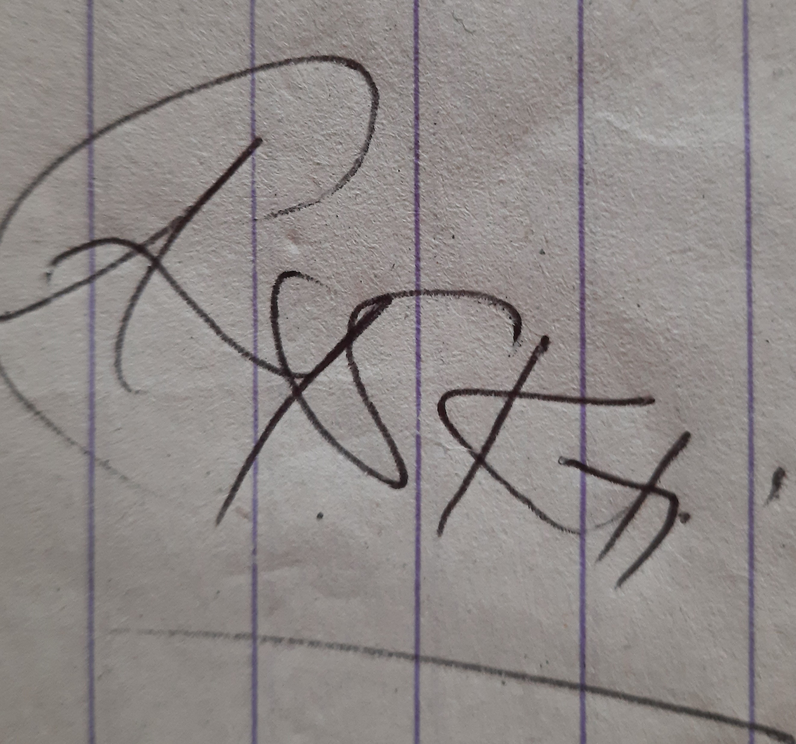 Date: - 2021/11/22

**You are strongly advised to retain a second copy of your work in case of any query about the assignment.**

**For completion by the faculty:**

**This mark is provisional and subject to moderation and approval by the relevant examining board**

**Teacher's Feedback**

**Teacher's Signature: __________________________________ Date: _________________**

Contents

Introduction To Database 3

Data Warehouse 4

Inmon and Kimball approach for data warehousing 5

Kimball vs Inmon approach in data warehousing 8

Data Modeling Schema’s 8

Introduction To Our Case Study 12

Data Dictionary for Dimension and Fact tables 14

Excel data for one of my reports to support my star-schema 18

Forward Engineer the star-schema to build DDL for data-mart 19

ETL (Extraction, Transformation, Loading) 23

Screen shots of running the codes related to stage crime 26

Screen shots of running the codes related to stage location 30

Screen shots of running the codes related to stage police officer 34

Separate clean and bad data from stage table 37

Screen shots for separating clean and bad data from crime 40

Screen shots for separating clean and bad data from crime 44

Screen shots for separating clean and bad data from police 48

Recleaning data from bad table 49

Re-clean bad data from bad_data_location 52

Re-clean bad data from bad_data_police 54

Transferring data from clean tables to transfer tables 56

Screen shots for data transfer from crime, location, and police 57

Loading data from transformation tables to Dimension tables 58

References 69

# Introduction To Database

Data has been a very integral part of human’s life since beginning, we’ve been evolving by collecting data around us and making something out of it which is useful. Generally, data related to business were stored in raw paper, diary etc., but gradually with time and technology the idea of data storage has been changed, with crores of data flowing in huge business and industries, there need to be more reliable and sophisticated way to store and later use those data for business purposes.

Businesses these days have two types of databases or let’s say there are two stages of data in any business, one when business perform transaction (transactional data or OLTP) and one when such transaction needs to be analyzed (OLAP). Transactional database is concerned with ongoing business activities whether it be to add new customer, update product. Developers use different powerful database system for such activities, oracle, PostgreSQL, MySQL.

When we talk about **Online Transaction Processing (OLTP)** we generally think of storing data physically as they are the action of business which needs to be captured for record. But eventually concept of OLTP has been extended with new technology introduced every other day, now with VoIP every call transaction, voice recording, images, videos, word document etc. are also stored in OLTP database for customer service and better security. Inserting, updating, and deleting are base for traditional OLTP database, which are solid base for new generation data.

**Online Analytical Processing Server (OLAP)** on the other hand is the software which performs multi-dimensional analysis on OLTP data and helps in business decision. Unlike, OLTP it doesn’t store or does any kind of business operation by storing in row or column rather it stores data from multiple sources in multi-dimensional data structure known as cubes in OLAP technology.

Difference between OLAP and OLTP

|  |  |  |
| --- | --- | --- |
| **S. N** | **OLAP** | **OLTP** |
| 1 | OLAP stores data in a multi-dimensional data structure for analyzing data. | OLTP are transaction related operation of a business which are stored in row and column format (RDBMS). |
| 2 | OLAP are time-variant, we have data over certain period. | OLTP are on-going, data is continuously flowing in business which needs to be stored |
| 3 | OLAP is used for data mining, Business Intelligence, predictions scenario and many more. | OLTP is used for recording all the on-going activities in any organization. |
| 4 | Data are generally fetched | Data are generally stored or updated |
| 5 | OLAP are subject-specific such as sales, marketing | OLTP are industry specific, such as manufacturing, banking |
| 6 | Data are generally in denormalized form for smooth querying of data | Data are normalized for reducing data redundancy |

# Data Warehouse

A lot of information revolves around us all the time. Such data when processed can give us very important information. Similarly, in any business or organization lots and lots of data are generated. Let’s take an example of an educational organization, in an educational organization there are many components of which we can record data such as students, teachers, staffs, management team, operation team, canteen etc. all this component of school carries its own specific data. Such data can be processed to improve our organization, for example if we want to improve condition of canteen we can analyze the data regarding canteen, we can see how many students eat in canteen, which day is more crowded, during which food students were more interested in eating canteen food. Apart from storing data for organizational requirement, such stored data can be used to improve the components which needs to be improved. Data Warehouse is the concept related to this. Stored data or OLTP data is processed, staged, and used for data analysis, decision-making.

Let’s understand data warehouse with the classical definition given by the father of data warehouse Bill Inmon, Data warehouse is a subject-orientated, integrated, time variant, non-volatile collection of data in support of management's decision-making process. [citing Lambert].

According to definition given by bill inmon, there are four keywords that explains the nature of data warehouse they are

* Time Variant
* Subject-orientated,
* Integrated,
* Non-volatile

**Time Variant**: In any organization whether it be education, governmental, financial, business there is always flow of data, such data are captured in day-to-day basis. When we analyze data then we choose certain time frame let’s say if we are in first week of December then we usually use the data of November for data analysis, so data warehouse is generally time variant.

**Subject-oriented**: When building data warehouse, we try to detach individual component of an organization for its individual analysis, when we say subject-oriented we mean individual analysis of individual business component.

**integrated**: organization can collect data from many sources, it may be in the form of text, csv, audio or also in bigger organization it may come from different branches, but to analyze the condition of organization we must collect all those data and analyze it accordingly, lots and lots of data from different sources will be integrated in a single repository for analysis.

**non-volatile**: In OLPT or transactional database, data changes often, but once data is loaded in data warehouse, we barely change any data making it non-volatile. If data is changed frequently in warehouse, then we might get ambiguous result affecting out business decision.

Data Mart

Datamart and data warehouse both stores’ data in central repository, only difference between them is data mart is more subject oriented whereas data warehouse stores data for the entire company. Querying data from data warehouse is comparatively harder, so we use data mart to provide easier access to end customers.

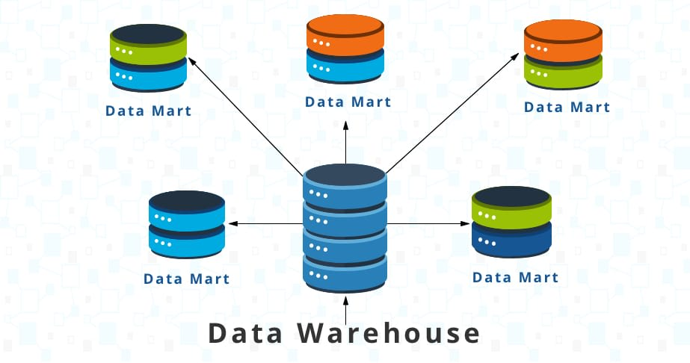

Fig: Datamart

## Inmon and Kimball approach for data warehousing

**The Inmon Approach:**

The core of Inmon’s approach is Enterprise data warehouse**,** this approach begins with finding the main subject areas for the organization like sales, loan etc. and modeling them logically. Such models will have sub-entities under them which are in normalized form making data model free from data redundancy and update anomalies. In this approach we first create our central repository also say data warehouse and only after that data marts are created from it. Diagram below shows the bus like structure for inmons approach, data from different sources are integrated, staged, and kept at a single container repository which is trusted source for designing further smaller containers called data marts.

[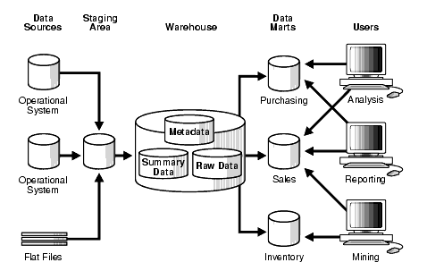](http://tdan.com/wp-content/uploads/2016/08/rangarajan01.png)

Figure 1.2, Source: Stanford. 2003. “Data Warehousing Concepts” https://web.stanford.edu/dept/itss/docs/oracle/10g/server.101/b10736/concept.htm#i1006297 (accessed 5/26/201

**Advantages of inmon-based approach:**

1. Main advantage of this model is that we get normalized data which makes our queries clearer and reduce update anomalies.
2. We will have the clear vision of business problem as business entities are modeled separately from each other.
3. We can easily extend our data warehouse as entities are modeled separately with each other, adding new entity will not affect the previous entities.

**Disadvantages of inmon-based approach:**

1. Designing this model can take more time as it involves excessive ETL process due to complex architecture.
2. Maintaining this model can cost more time and money.
3. A large team of specialists need to be around to successfully manage the environment (Breslin, 2004)

**The Kimball Approach:**

Kimball approach of data warehouse is also called bottom-up approach, as we first design data-marts for specific business process and later combine all these data marts into a single repository forming an enterprise data warehouse. The fundamental concept of dimension modeling is star schema. We design star schema which consists of dimension table which are descriptive in nature and fact table which contains all the factual data. Fact table is surrounded by denormalized dimension table, contains foreign keys from these dimension tables and has all the calculative measures stored in it. We fetch required data from fact table to produce report regarding specific topics. Multiple star schemas are later integrated for fetching relative data from various business model to generate complex business reports.

[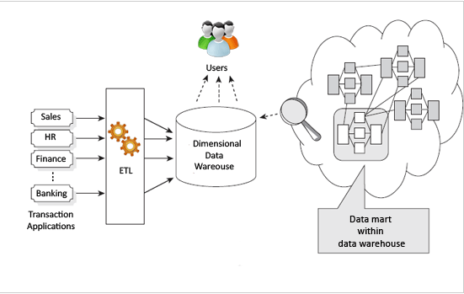](http://tdan.com/wp-content/uploads/2016/08/rangarajan02.png)

Figure 1.3, Source: Zentut. 2016. “Ralph Kimball Data Warehouse Architecture” http://www.zentut.com/data-warehouse/ralph-kimball-data-warehouse-architecture (accessed 5/25/2016)

**Advantages of kimball-based approach:**

1. Kimball-based data warehouse avoids complex modeling as it implements denormalized dimension tables.
2. Designing cost of kimball’s approach is relatively lesser than inmons.
3. In Kimball-based approach, study of individual components is way easier as we have individual data-marts for specific components.
4. It is relatively easy to understand, which is useful as we can consult this model with non-technical members.

**Disadvantages of Kimball-based approach:**

1. As we use denormalized data, chances of data redundancy are maximum which creates higher possibility for errors.
2. Although designing kimball-based approach a bit faster but we lose flexibility on the way.

### Kimball vs Inmon approach in data warehousing

Kimball approach for data warehousing is just the polished or re-engineered version of Inmon approach, both suggest the central repository architecture for modeling data and ETL process for loading data in warehouse. There is not as such thing as one approach is better than other, it depends upon the objective of business. The key difference between the model proposed by Kimball and inmon for data warehousing is that the dimensional models in kimball’s approach is not normalized.

We design dimension table and fact table for modeling any kind of data warehouse whether it be Inmon or Kimball, dimension table are modeled to store descriptive data required for our analysis and fact table stores all the quantitative measure for our analysis. If we want to search for dimension and fact table, we need to have clear picture of what we are searching for in our data, let’s suppose in our case study, we have different sector for measuring KPI of crime scene in England. As I am assigned for KPI1 that is Reduce Crime lets analyze our data to look for required description and measures for finding dimension and fact table.

### Data Modeling Schema’s

**Star, snowflake, and star flake schema** are the set of instruction about how our dimension and fact table are modeled in data warehouse. Inmons and kimballs approach, as discussed earlier suggest different ideas for designing data warehouse model, one talked about normalized data sets and other suggests denormalized data sets, these ideas were later defined, tested, and documented to form star, snowflake, and star flake schema. Before moving forward let’s understand what dimension and fact table are.

**Dimension table**:

when we want to analyze our business, we do that by understanding different aspects of our business, for example Loan, Customer or say Employee, this are the topic that we want to discuss about when we want to analyze bank related data. Those data that we are interested in are modeled and all the descriptive details related with this model are stored in a particular table, which we call as dimension table. Dimension table only stores descriptive data about the topic that we want to know about.

**Fact table**:

Now that we have all the dimensions we want to know about, we want to take out facts about this dimension tables, say we want to know about number of customers that aren’t paying loan on time, we create a fact table where all the primary key from dimension table along with the measures that we want to know about this dimension are stored. Generally, we have only one fact table for a specific business aspect.

**Granularity of data:**

Granularity means the depth of detail that our fact table carries. Our fact table consists of one or many dimensions and it is responsible for answering the query related to those dimensions. When we generate reports regarding to a certain aspect of our business, to how much depth can our fact table answer the query asked by business professionals is the granularity of data.

**star schema:**

As the name suggests, when dimension table and fact table are arranged in such a way where we can form an image of star such schema is termed as star schema. How can we arrange dimension and fact that can be imagined as star schema? Well, let’s see a picture to answer this question

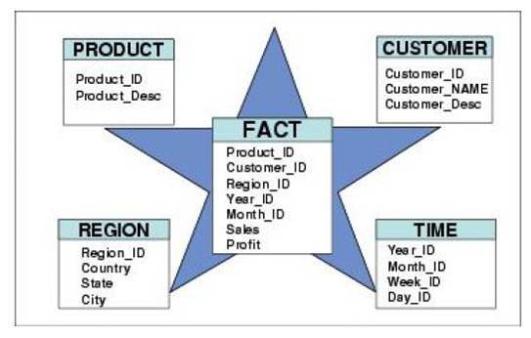 **Fig: Star Schema**

As we can see, Dimension (descriptive) data set are only building relation with fact table, that is data sets are in denormalized form, dimension can’t have sub-dimension under them, or dimension cannot build relation with another dimension in star schema. Fact table stays in the middle, has the foreign key of all the dimensions.

**Snowflake schema:**

In snowflake schema, dimension table have its sub table under it i.e., dimension table can build relation with other dimensions. Fact table do have foreign keys from all the main dimension table but doesn’t contain foreign key of all the dimensions, as we can see in the picture given below. When we normalize all the denormalized dimension table from star schema than snowflake schema is formed, basically it is the expansion of star schema.

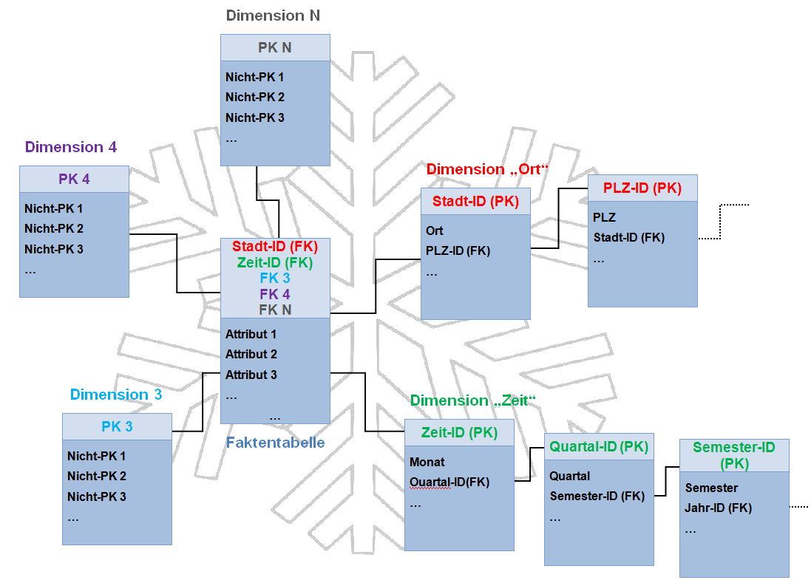**Fig: Snowflake Schema**

**Star flake schema:** snowflake schema is the mixture of star and snowflake schema. Star flake schemas are snowflake schemas where only some of the dimension tables have been denormalized.

It has basic structure of star schema with some of the dimension normalized to fit the need of the criteria.

**Difference Between Star schema and snowflake schema**

|  |  |  |
| --- | --- | --- |
| S N | Star schema | Snowflake schema |
| 1 | Dimension tables are in denormalized form and only related to fact table | Dimension tables are in normalized form, dimension can have sub dimensions |
| 2 | Less time for execution of queries due to less joins between tables | Querying takes a little more time due to more joins between tables |
| 3 | Understanding star schema is little bit easier as they are in denormalized form | Understanding snowflake schema is comparatively harder than star schema. |
| 4 | Needs less memory in comparison to snowflake, as it contains lesser tables | Needs more memory space as it contains more tables |
| 5 | Handling and maintaining this model is quite easier due to simple architecture | Handling and maintaining this model is quite harder due to complex architecture |

**ETL (Extraction, Transformation, Loading)**, is the process which involves extraction of data from various sources such as database, text, csv, or data over the internet, transforming such data by performing all the necessary operation such as cleansing, adding surrogate key etc. for making it able to be analyzed and finally loading it into the data warehouse, figure below shows the extraction transformation and loading process in ETL.

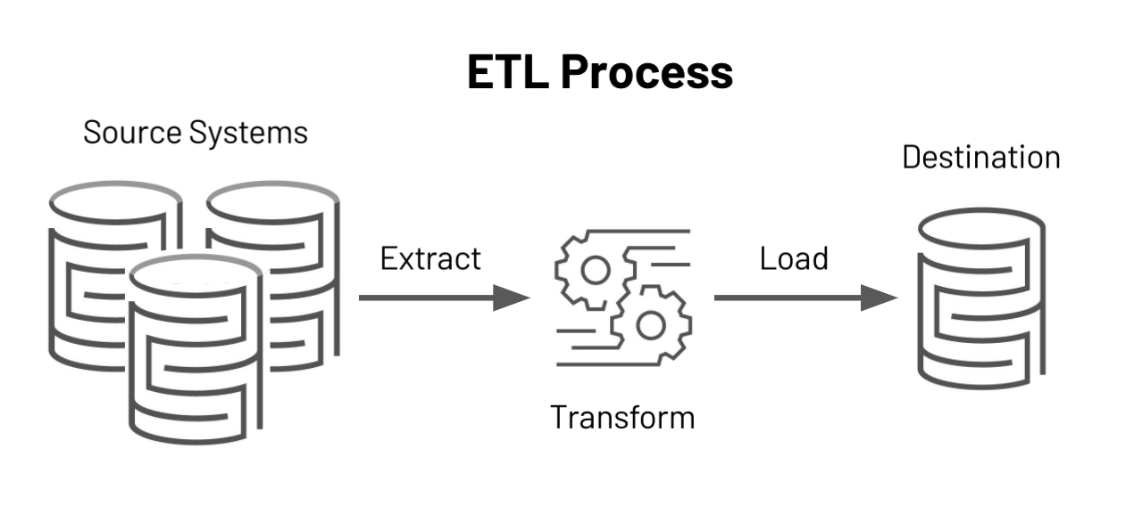

Fig: ETL process

Transaction process includes

**Cleansing**: unwanted and missing values are resolved.

**Standardization**: data needs to be standard as it contains data from various sources, standard rules are stated and followed through out.

**Deduplication**: problem regarding redundant data is solved.

**Verification**: authenticating important data sets.

# Introduction To Our Case Study

There are regional stations around England that records crime related data of its region, all these stations have a lead police officer. When any crime is reported it is immediately reported in its reginal station, crime may be new ongoing or closed. Reported crime may last from 1 month up to a year but some cases may last even more, it depends upon the case. Crimes are revised yearly until they are closed, every crime belongs to certain station and is supervised by a lead officer. Some crimes may be escalated to a higher level that the ‘station’ in which case their status is marked as ‘escalated’.

We are provided with some OLTP data in different formats,

* PRCS.sql and PRCS_insert_test_data.sql
* PS_Wales.sql
* A spreadsheet of crimes in Leeds

these data sources have data related to committed crimes throughout England, but they are in different nature as they were recorded in different place and time. Our job is to collect and integrate data from all these different sources and to give some useful information that will help as a measure for key performance indicator (KPI). I am hired as a data analyst for designing data warehouse, data mart to be more particular as we will look at a particular KPI assigned for us. Crime branch of England wants me to work on indicator that measure the performance related to reducing crime.

First, we will get familiar with the data source that we will work on. We are provided with two database management system, one used by the Police in England to record crimes and other for Wales only. Both databases have similar structure, but they are not same, we must analyze the given database management systems and design data model for the KPI that we are assigned. We will now look for the possible question that can be raised for reducing crime. These questions will later be documented as reports, our data modeling will be based on these reports. We will only focus on the main theme that our report suggests.

After analyzing data from these provided systems, I have generated certain reports,

1. Number of crimes solved by a particular police officer in a year.
2. Number of crime types pending according to location.
3. How frequently is same crime happening in a particular location in a year.
4. What kind of crime is pending for longer period?
5. Number of crimes solved with in a day.

Also, other queries such as

* Number of police officer required to solve a particular case.
* What kind of crime is common and are frequently happening?
* What kind of crime were popular in which year?

Can be answered by the model that we are going to design. To answer these reports, we should find out the specific area around which our query revolves, for example, we are frequently talking about crime, police officer, location so that means we want to know about these specific subjects. As we know, dimension table stores the descriptive data hence we generate dimension table for **CRIME**, **LOCATION**, **POLICE_OFFICER**. Following the common practice we will generate a dimension table for time, this will help reduce us query complexity. Similarly, we will have a separate fact table that builds relation with every other dimension table and stores measures regarding it.

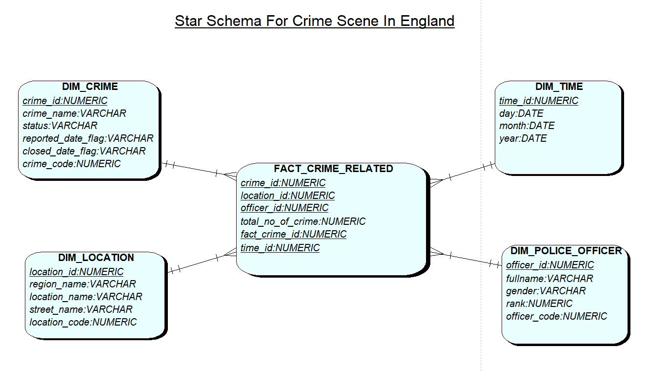

Fig: Star Schema

## Data Dictionary for Dimension and Fact tables

It is very hard to track down data, once its staged and loaded in dimension and fact table. Also, the dimension modeling of the system is revised with time, so suppose If we want to update our model then we must have some kind od documentation that will help us understand how and from where our model was designed. Documenting data model helps for new data-warehousing team to understand pre-existing model. Data dictionary is also a part of documenting data. I documented all the dimension tables and a fact table; this will help me further in my data-warehousing process.

**DIM_CRIME**

|  |  |  |  |  |  |  |
| --- | --- | --- | --- | --- | --- | --- |
| Column | Data type | Column type (SK, PK, FK, | Definition, could be used a help text | Example data  To clarify the content of the attribute esp for flags, codes | Source element and transformation | Quality OR Transformation rule. May include pseudo-sql |
| crime_id | numeric | pk | Uniquely identifies each row of crime dimensions. Surrogate key generated for new record | 1 | Generated by sequence seq_stage_crime | No need to transfer as surrogate key is used. |
| crime_name | varchar | - | Name of offence such theft, kidnapping | theft | Extracted from ps_wales and prcs database systems, crime_register and pl_reported_crime | Valid name for crime. |
| status | varchar | - | Status of crime, i.e., is it open or is it solved | open | Extracted from ps_wales and prcs database systems, crime_register and pl_reported_crime | Either be open, closed or escalate  e.g if open and closed_date null then insert into clean_data. |
| reported_date_flag | varchar | - | Either reported date was recorded or not | Y (y/n) | Extracted from ps_wales and prcs database systems, crime_register and pl_reported_crime | If reported_date then reported_date_flag is Y. |
| closed_date_flag | varchar | - | Either closed date was recorded or not | N (y/n) | Extracted from ps_wales and prcs database systems, crime_register and pl_reported_crime | If closed_date then closed_date_flag is Y. |
| crime_code | numeric |  | Primary key taken from source table | 100 | Pk of crime_register and pl_reported_crime | Transformed as it is |

|  |  |  |  |  |  |  |
| --- | --- | --- | --- | --- | --- | --- |
| Column | Data type | Column type (SK, PK, FK, | Definition, could be used a help text | Example data  To clarify the content of the attribute esp for flags, codes | Source element and transformation | Transformation rule. May include pseudo-sql |
| Officer_code | numeric | pk | Pk from source table | 1 | Extracted from ps_wales and prcs database systems, officer and pl_police_employee | Transformed as it is |
| Officer_id | numeric | - | Uniquely identifies DIM_POLICE_OFFCER | 11 | Generated from sequence seq_police_officer | Transformed as it is from transformation table |
| Full_name | varchar | - | Name of the officer | Rafael | Same as officer_code | Aggregate first_name, middle_name, and last_name as single full_name |
| rank | numeric | - | Position of officer given to them based on their work log | 10 | Same as officer_code | Transformed as it is |
| gender | varchar | - | Either male or female | male | Same as officer_code | Transformed as it is |

**DIM_POLICE_OFFICCER**

|  |  |  |  |  |  |  |
| --- | --- | --- | --- | --- | --- | --- |
| Column | Data type | Column type (SK, PK, FK, | Definition, could be used a help text | Example data  To clarify the content of the attribute esp for flags, codes | Source element and transformation | Transformation rule. May include pseudo-sql |
| Time_id | numeric | pk | Uniquely identifies every record in time dimension | 1 | Generated by sequence | - |
| day | date | - | Represent every day in a fiscal year | 10 | Generated using some in-built function or make myself one | - |
| month | date | - | Represent all the month in a year | 09 | Generated using some in-built function or make myself one | - |
| year | date | - | Represent particular year | 2021 | Generated using some in-built function or make myself one | - |

**DIM_TIME**

|  |  |  |  |  |  |  |
| --- | --- | --- | --- | --- | --- | --- |
| Column | Data type | Column type (SK, PK, FK, | Definition, could be used a help text | Example data  To clarify the content of the attribute esp for flags, codes | Source element and transformation | Transformation rule. May include pseudo-sql |
| location_id | numeric | pk | Uniquely identifies every record in location dimension | 1 | Generated by sequence | Transformed as it is |
| Region_name | varchar | - | Name of the region | Yorkshire | Extracted from ps_wales and prcs database systems, region and pl_area | Transformed as it is from transform_location table |
| Location_name | varchar | - | Name of location inside region | Kings cross | Extracted from ps_wales and prcs database systems, location and pl_station | Transformed as it is from transform_location table |
| Street_name | varchar | - | Name of street inside location | Street1 | Extracted from ps_wales and prcs database systems, location | Transformed as it is from transform_location table if it is present |
| Location_code | numeric | - | Pk from source table | 3 | Extracted from ps_wales and prcs database systems, location and pl_station | Transformed as it is from transform_location table |

**DIM_LOCATION**

**FACT_CRIME**

|  |  |
| --- | --- |
| Process, description of fact table and measures | This fact table is designed to answer the questions related to reducing crime, based on KPI 1. Its carries fact related to crime, police officer assigned and location where the crime took place. |
| Grain, exact level of data for each row of data | Fact_crime table gives the granularity or details of crime related to time, location, crime type and police officer let’s say, which police officer is solving what crime. |
| PK’s | Fact_crime_id – surrogate PK from a sequence |
| FK’s | Time_id , crime_id, location_id, officer_id, |
| List facts (measures) | Total_no_of_crime |
| List dimensions that are used with this fact | DIM_TIM, DIM_LOCATION, DIM_CRIME, DIM_POLICE_OFFICER |

## Excel data for one of my reports to support my star-schema

The report that I am going to illustrate via excel is **Number of crime types pending according to location**

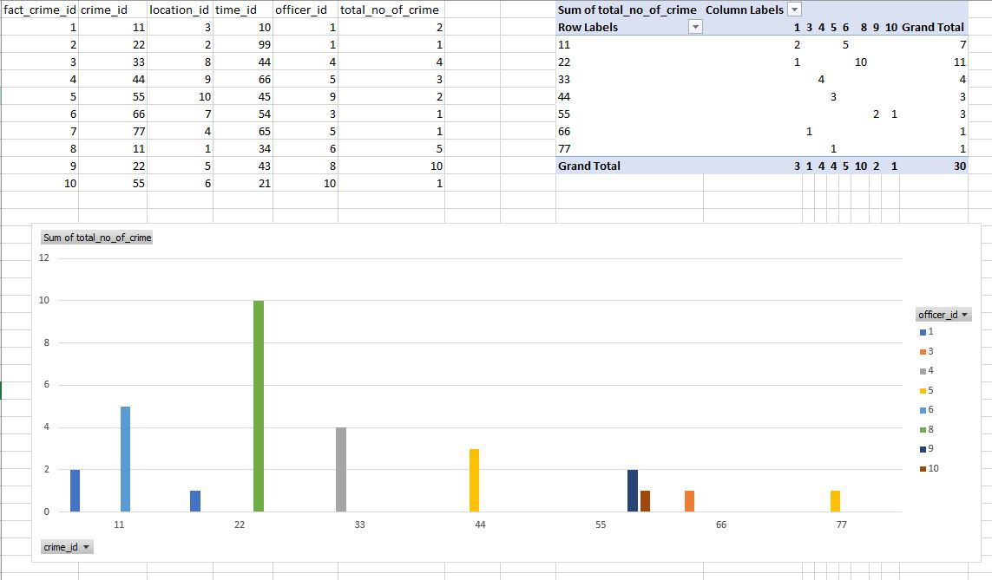

## Forward Engineer the star-schema to build DDL for data-mart

In QSEE (tool that we used to design star-schema), its very easy to generate DDL statement for our schema, just right click in the playground and select the option generate DDL.

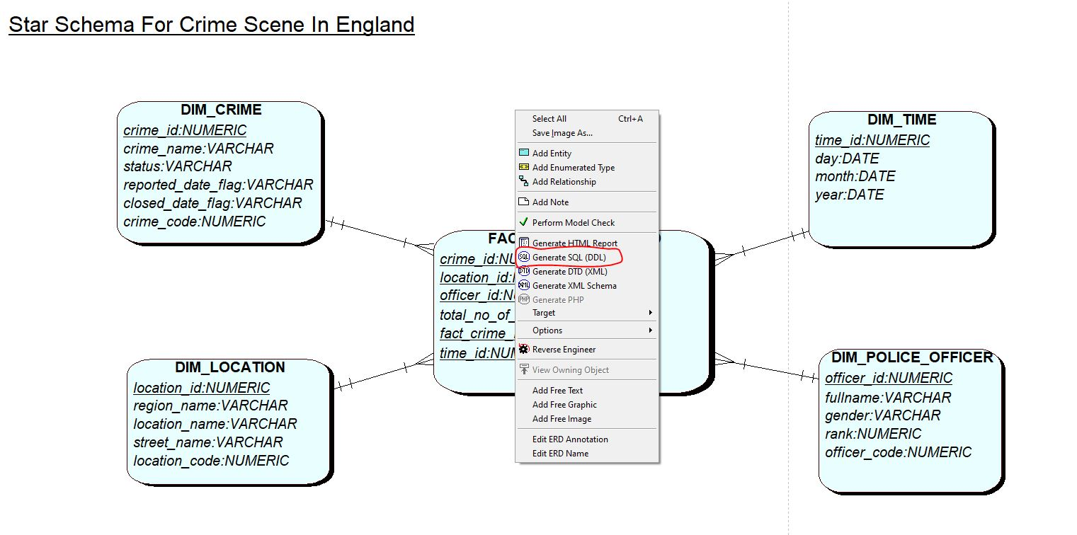

This will generate a text file with rough DDL statements, we then load this file in our apex oracle environment and create DDL script.

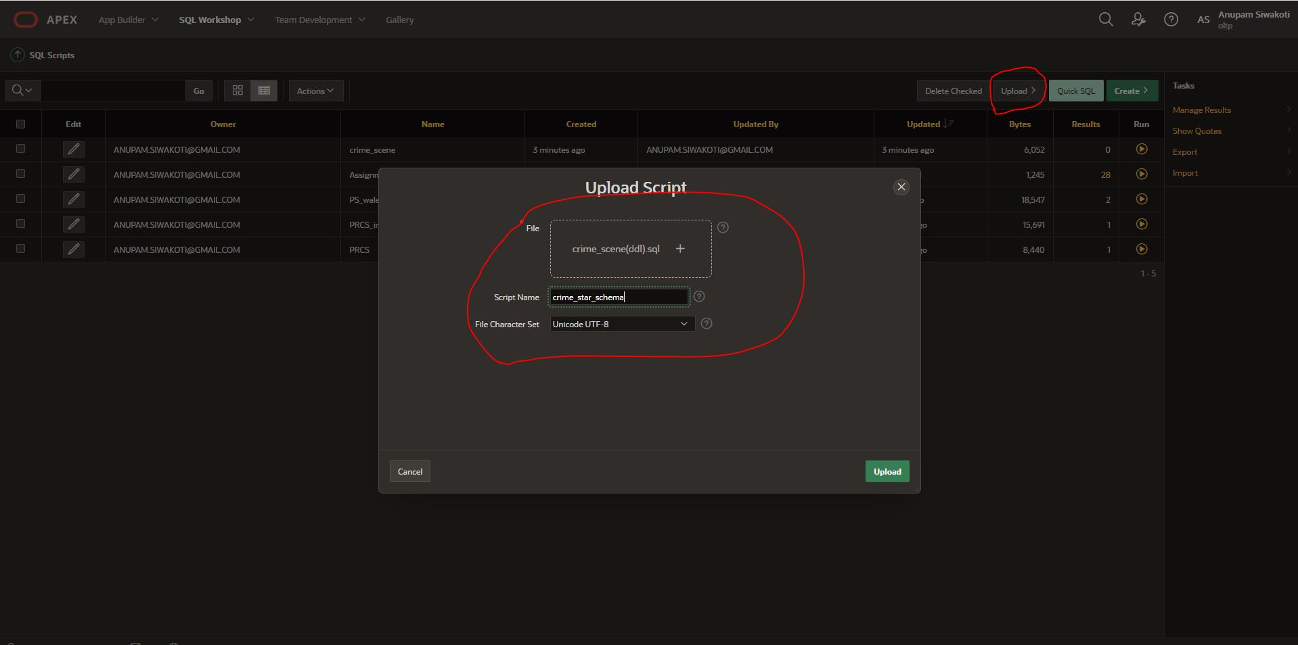

After uploading our DDL file we then run the script to create the physical form of our star-schema.

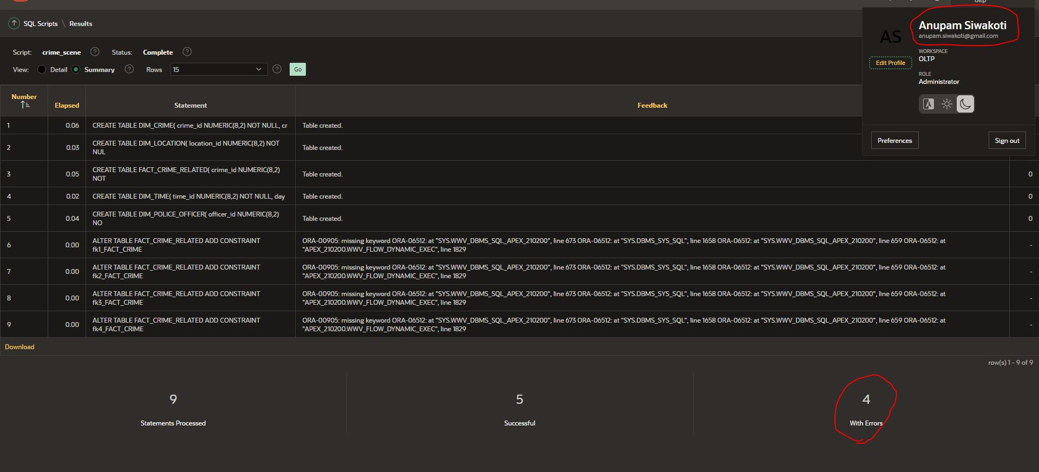

We find lots of error when we run our script for the first time, its because automatically generated DDL statement will off course have some errors, lets solve all this error and run our clean script successfully.

I have erased all the in-built comments which were generated with the DDL statements. Let’s see screen shots of all the self-generated SQL commands.

Screenshots of generated code

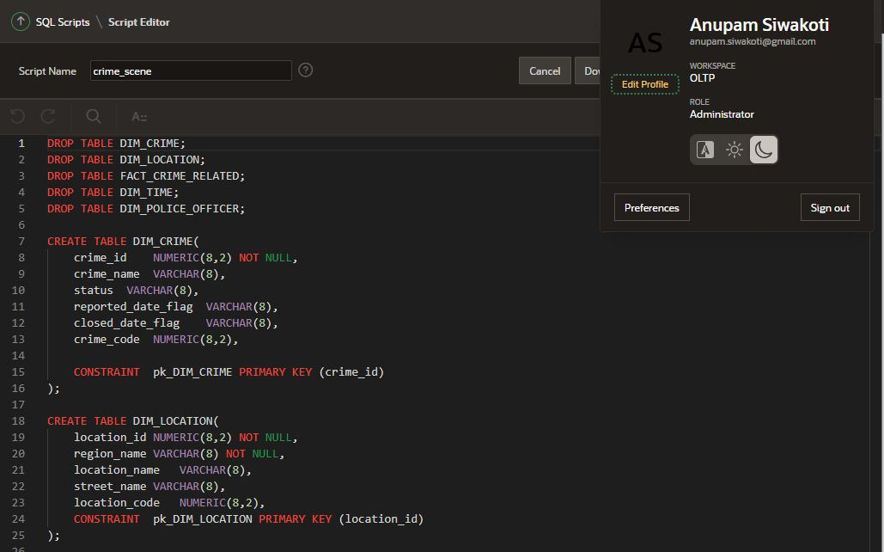

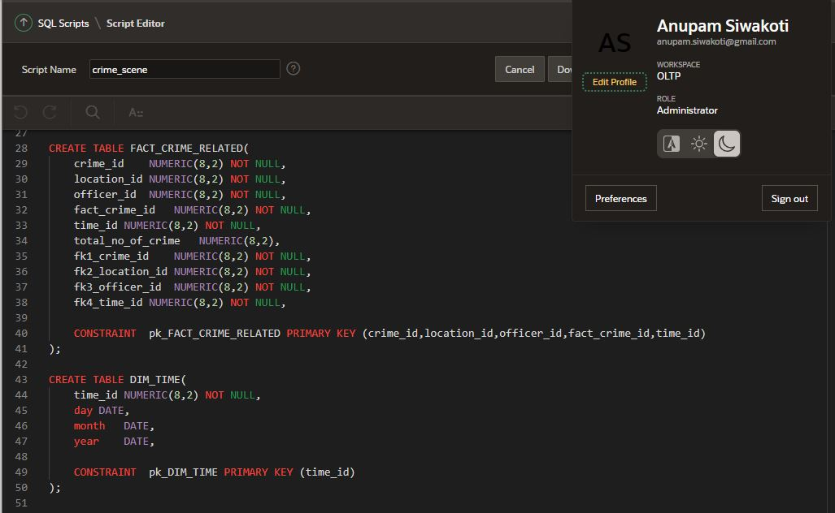

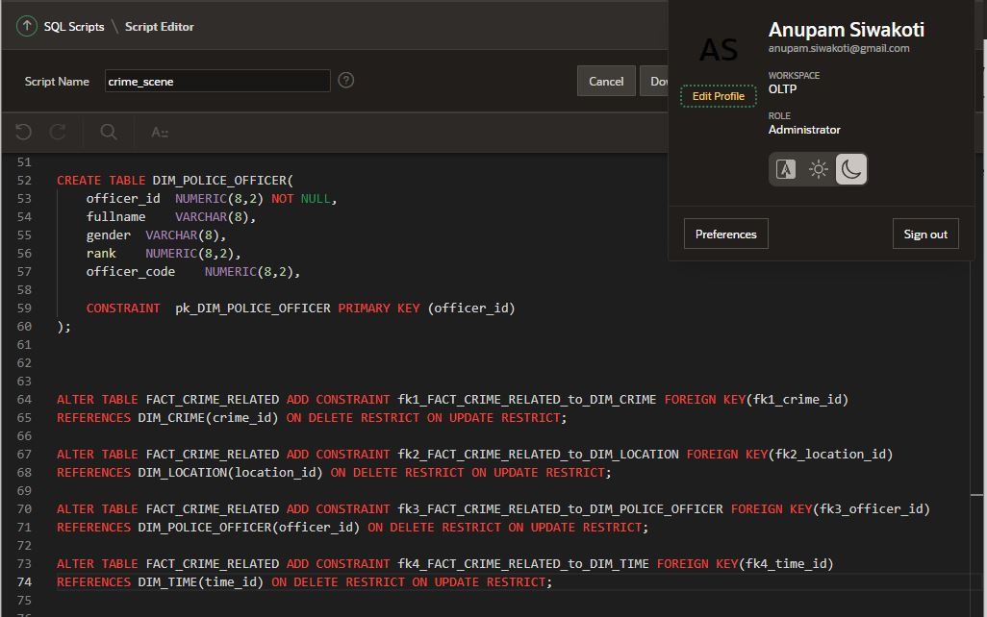

**Encountered Error**

All the tables were created without any problem, but it seems to have problem when we alter table to add foreign key.

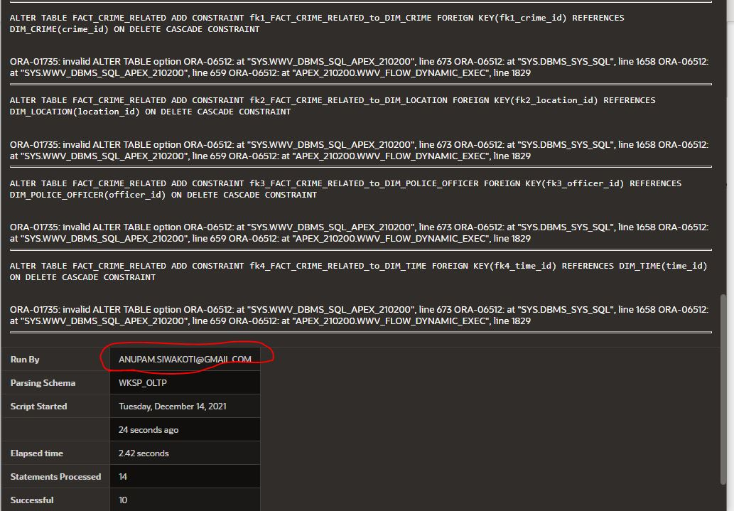

This problem was solved when I removed ON DELETE RESTRICT ON UPDATE RESTRICT

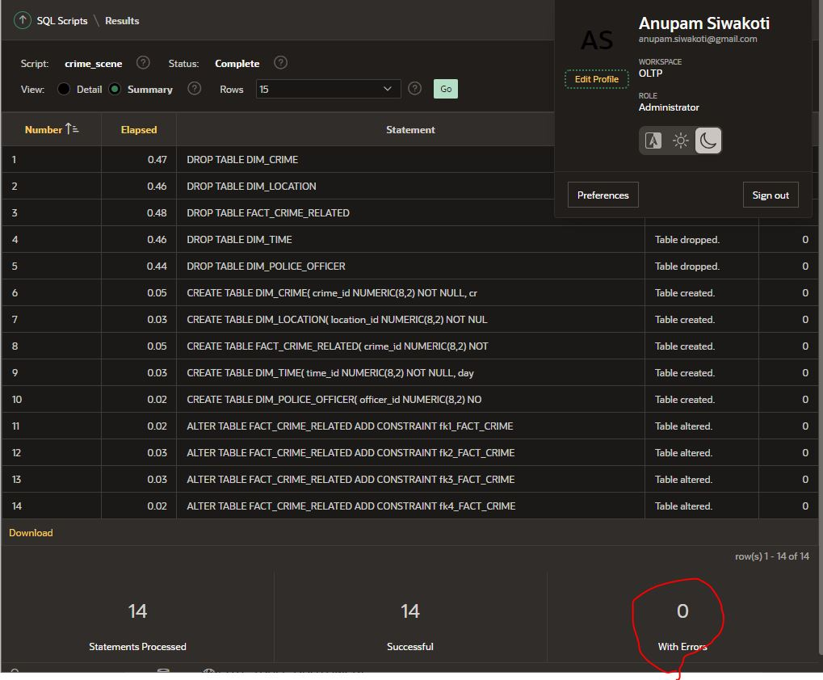

# ETL (Extraction, Transformation, Loading)

Till now we designed our star-schema, forward engineered this schema to have physical representation of our logical model. Now, we must extract all the necessary data from our database system, process it to satisfy our reports. To begin our ETL process, we need to analyze what kind of data is to be loaded in dimension and fact table. In our case we have four dimensions, **DIM_CRIME**, **DIM_TIME**, **DIM_LOCATION** and **DIM_POLICE_OFFICER.** We need a stage table to store the data that we extract from multiple sources. Data in stage table is denormalized in star-schema. We create three stage table for DIM_CRIME, DIM_LOCATION and DIM_POLICE_OFFICER. Let’s see an example of DIM_CRIME to have clear vision about it.

Data in DIM_CRIME will be extracted from two tables i.e., crime_register from **PS_WALES** and pl_reported_crime from **PCRS**. First we create a stage table, in this table we will store all the relation of the original table, all the dates and other required data because we need to take this data and maintain relation of the data till transformation process.

**CREATE TABLE stage_crime(**

**crime_id NUMERIC(8,2) NOT NULL,**

**crime_code NUMERIC(8,2),**

**crime_name VARCHAR2(20),**

**status VARCHAR2(20),**

**reported_date DATE,**

**closed_date DATE,**

**police_officer_id NUMERIC(8,2),**

**location_id NUMERIC(8,2),**

**db_source VARCHAR2(30),**

**CONSTRAINT pk_crime_id PRIMARY KEY (crime_id)**

**);**

As we can see, we have all the data including foreign keys and it is denormalized, how is it denormalized? Well if you see closely we have a attribute named police_officer_id. In crime_register we are provided with police_id so we can directly fetch data from crime_register and put in it, but what about pl_reported_crime?

So here to accomplish this we have denormalized two tables from PRCS, one is pl_reported_crimw and another is pl_work_allocation. There is a relation between pl_reported_crime and pl_work_allocation, this were separated in OLTP to have normalized set of data. We used join statement between pl_reported_crime and pl_work_allocation to select required data and insert in out stage table. Before showing this let us create sequence for automatic creation of new surrogate key for our stage table and trigger to fire this sequence whenever new record is inserted.

**Sequence for stage crime**

**create sequence seq_stage_crime**

**Minvalue 1**

**MaxValue 100000**

**Start With 1**

**Increment by 1;**

**Trigger for stage crime**

**CREATE OR REPLACE TRIGGER tr_stage_crime**

**BEFORE INSERT ON stage_crime**

**FOR EACH ROW**

**BEGIN**

**SELECT seq_stage_crime.NEXTVAL INTO :NEW.crime_id FROM SYS.DUAL;**

**END tr_stage_crime;**

**Procedure to insert data in stage crime**

**create or replace procedure sp_stage_crime is**

**begin**

**MERGE INTO stage_crime t_crime**

**USING crime_register s_crime**

**ON (t_crime.crime_code = s_crime.crime_id and t_crime.police_officer_id = s_crime.police_id)**

**WHEN NOT MATCHED THEN**

**INSERT (crime_code, crime_name, status, reported_date, closed_date, police_officer_id, location_id, db_source)**

**VALUES (s_crime.crime_id, s_crime.crime_name, s_crime.crime_status, TO_DATE(s_crime.reported_date, 'MM/DD/YY'), TO_DATE(s_crime.closed_date, 'MM/DD/YY'), s_crime.police_id, s_crime.location_id, 'ps_wales');**

**MERGE INTO stage_crime t_crime**

**USING (SELECT c_reported.reported_crime_id, c_type.crime_type_desc, c_reported.crime_status,c_reported.date_reported, c_reported.date_closed, p_allocation.d_emp_id , c_reported.fk2_station_id**

**from pl_reported_crime c_reported INNER JOIN pl_crime_type c_type ON c_reported.FK1_CRIME_TYPE_ID = c_type.CRIME_TYPE_ID**

**full JOIN pl_work_allocation p_allocation ON p_allocation.s_reported_crime_id = c_reported.reported_crime_id) s_crime**

**ON (t_crime.crime_code = s_crime.reported_crime_id and t_crime.police_officer_id = s_crime.d_emp_id)**

**WHEN NOT MATCHED THEN**

**INSERT (crime_code, crime_name, status, reported_date, closed_date, police_officer_id, location_id, db_source)**

**VALUES (s_crime.reported_crime_id , s_crime.CRIME_TYPE_DESC, s_crime.crime_status, TO_DATE(s_crime.DATE_REPORTED, 'MM/DD/YY'), TO_DATE(s_crime.DATE_CLOSED, 'MM/DD/YY'), s_crime.d_emp_id ,s_crime.fk2_station_id, 'prcs');**

**end sp_stage_crime;**

## Screen shots of running the codes related to stage crime

**Creating Table**

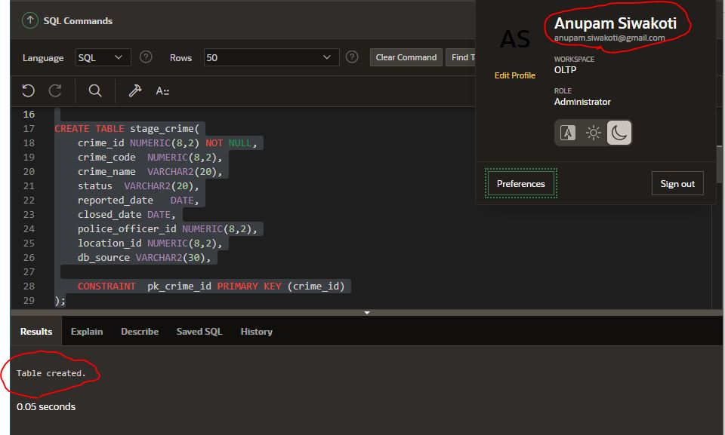

**Creating Sequence**

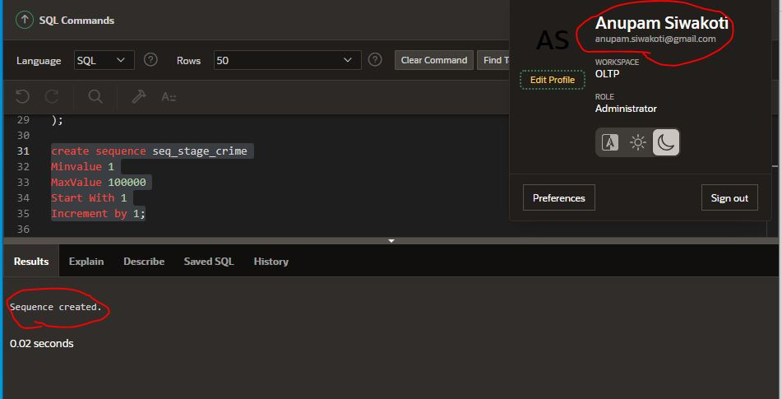

**Creating Procedure for stage crime**

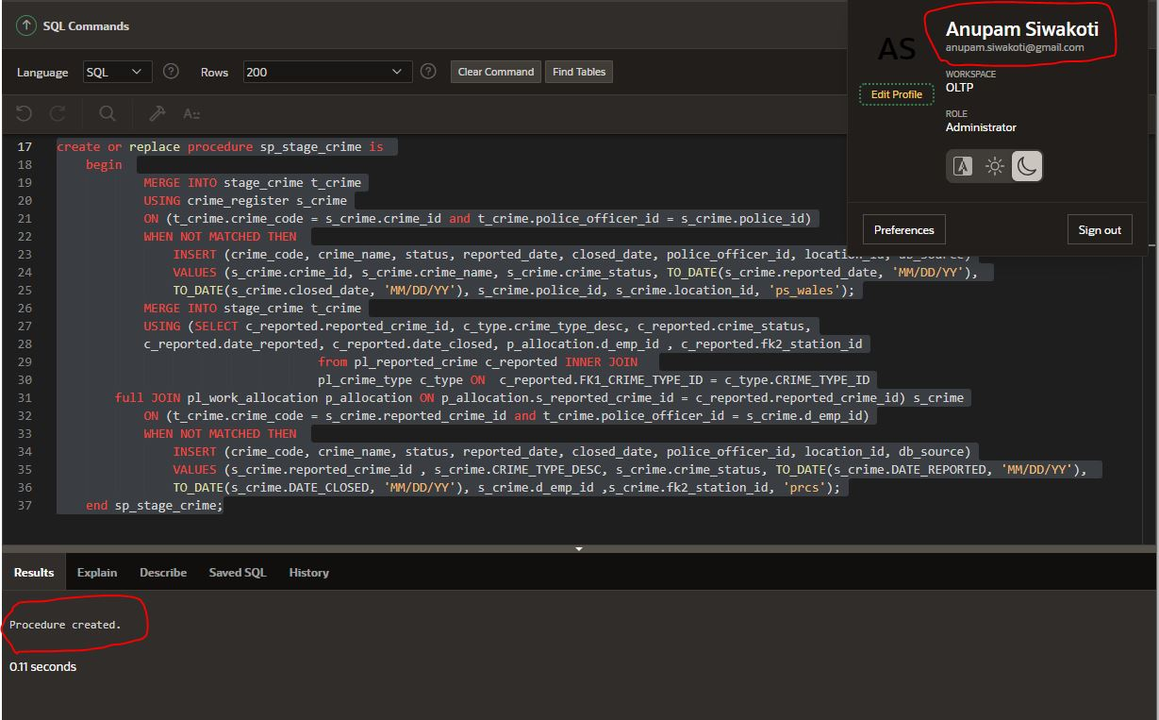

**Running the procedure to insert data in sequence**

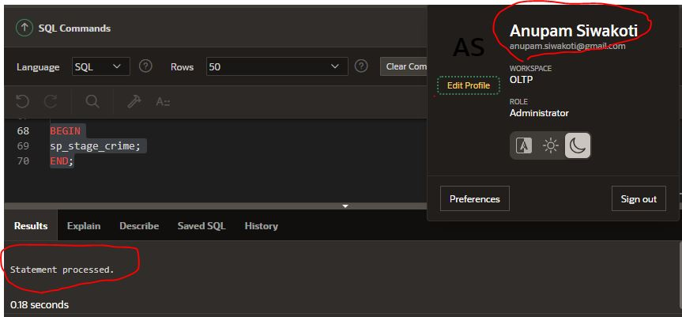

**Selecting stage crime to see if data is loaded or not**

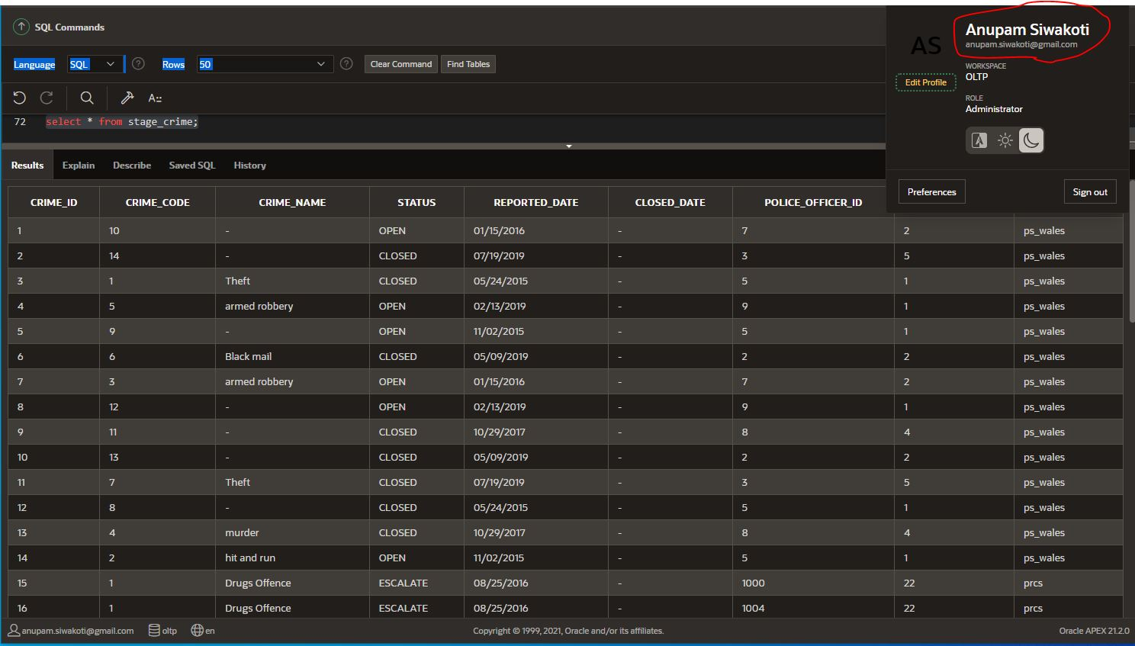

Now that we loaded data and saw how we denormalized data while staging crime. Let’s stage location as well. To stage data we extract data from location and pl_station, these two tables have relation with region and pl_area table respectively. We extract the value of region by joining location and region table from **PS_WALES** database, similarly we extract the value of area by joining pl_station and pl_area from **PRCS** database.

**Create stage location**

**CREATE TABLE clean_data_location(**

**clean_location_id NUMERIC(8,2) NOT NULL,**

**location_code NUMERIC(8,2),**

**location_name VARCHAR2(20),**

**region_id NUMERIC(8,2),**

**db_source VARCHAR2(30),**

**CONSTRAINT pk_clean_location_id PRIMARY KEY (clean_location_id)**

**);**

We also create a sequence to generate new surrogate every time new record is inserted in stage location. This surrogate is used by trigger whenever new record is created for stage location.

**Sequence for stage location**

**create sequence seq_stage_location**

**Minvalue 1**

**MaxValue 100000**

**Start With 1**

**Increment by 1;**

**Trigger for stage location**

**CREATE OR REPLACE TRIGGER tr_stage_location**

**BEFORE INSERT ON stage_location**

**FOR EACH ROW**

**BEGIN**

**SELECT seq_stage_location.NEXTVAL INTO :NEW.location_id FROM SYS.DUAL;**

**END tr_stage_location;**

**Procedure for stage location**

**create or replace procedure sp_stage_location is**

**begin**

**MERGE INTO stage_location t_location**

**USING location s_location**

**ON (t_location.location_code = s_location.location_id and t_location.location_name = s_location.city_name)**

**WHEN NOT MATCHED THEN**

**INSERT (location_code, location_name, region_id, db_source)**

**VALUES (s_location.location_id,s_location.city_name,s_location.region_id,'ps_wales' );**

**MERGE INTO stage_location t_location**

**USING pl_station s_location**

**ON (t_location.location_code = s_location.station_id and t_location.location_name = s_location.station_name)**

**WHEN NOT MATCHED THEN**

**INSERT (location_code, location_name, region_id, db_source)**

**VALUES (s_location.station_id,s_location.STATION_NAME,s_location.fk1_area_id, 'prcs');**

**end sp_stage_location;**

## Screen shots of running the codes related to stage location

**Create Table**

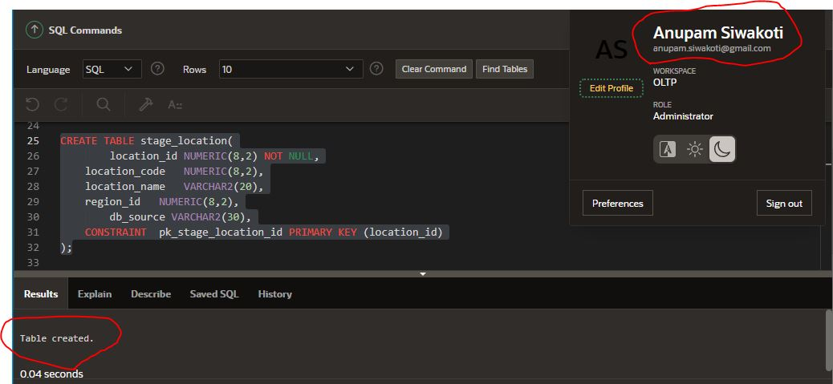

**Create Sequence**

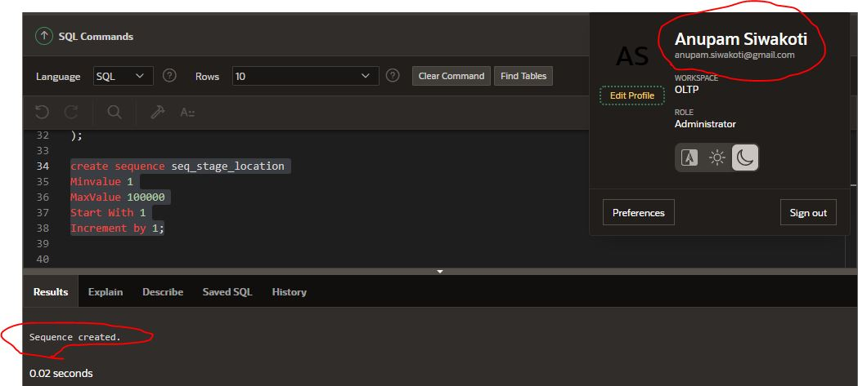

**Create Trigger**

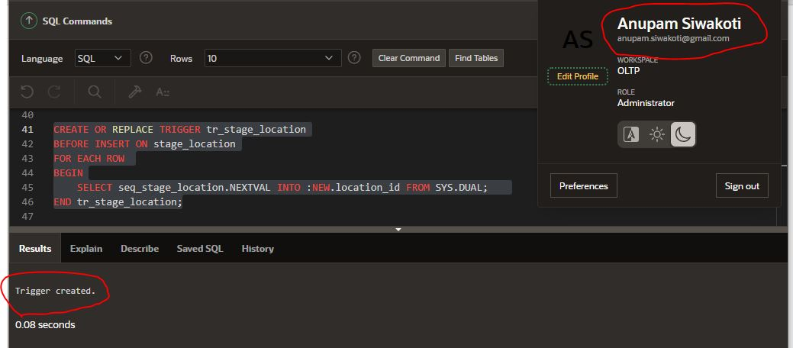

**Create Procedure**

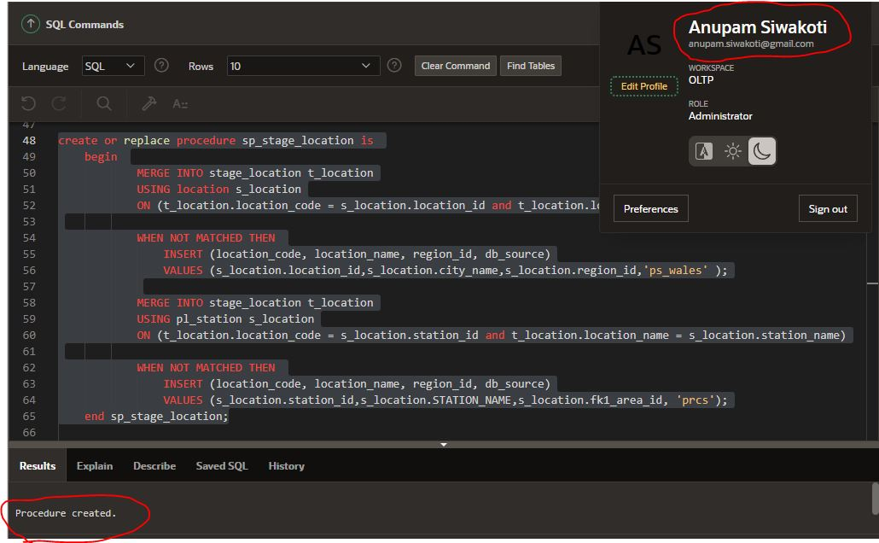

We do the same process while staging police officer data from these two databases. We extract data of officer table from **PS_WALES** and of pl_police_employee from **PRCS**.

**Create stage police officer**

**CREATE TABLE stage_police_officer(**

**police_id NUMERIC(8,2) NOT NULL,**

**police_code NUMERIC(8,2),**

**police_first_name VARCHAR2(20),**

**police_middle_name VARCHAR2(20),**

**police_last_name VARCHAR2(20),**

**gender VARCHAR2(20),**

**rank VARCHAR2(20),**

**db_source VARCHAR2(30),**

**CONSTRAINT pk_stage_police_id PRIMARY KEY (police_id)**

**);**

**Create sequence for stage police officer**

**create sequence seq_police_officer**

**Minvalue 1**

**MaxValue 100000**

**Start With 1**

**Increment by 1;**

**Create trigger for stage police officer**

**create or replace TRIGGER tr_police_officer**

**BEFORE INSERT ON stage_police_officer**

**FOR EACH ROW**

**BEGIN**

**SELECT seq_police_officer.NEXTVAL INTO :NEW.police_id FROM SYS.DUAL;**

**END tr_police_officer;**

P**rocedure for stage police officer**

**create or replace procedure sp_stage_police_officer is**

**begin**

**MERGE INTO stage_police_officer t_officer**

**USING officer s_officer**

**ON (t_officer.police_code = s_officer.officer_id)**

**WHEN NOT MATCHED THEN**

**INSERT (police_code, police_first_name, police_middle_name, police_last_name, gender, rank, db_source)**

**VALUES (s_officer.officer_id,s_officer.first_name, s_officer.middle_name, s_officer.last_name, s_officer.gender , s_officer.rank, 'officer (ps_wales)');**

**MERGE INTO stage_police_officer t_officer**

**USING pl_police_employee s_officer**

**ON (t_officer.police_code = s_officer.emp_id)**

**WHEN NOT MATCHED THEN**

**INSERT (police_code, police_first_name, police_middle_name, police_last_name,gender, rank, db_source)**

**VALUES (s_officer.emp_id,s_officer.emp_name,null, null, null,s_officer.emp_grade, 'pl_police_employee (prcs)');**

**end sp_stage_police_officer;**

## Screen shots of running the codes related to stage police officer

**Create Table**

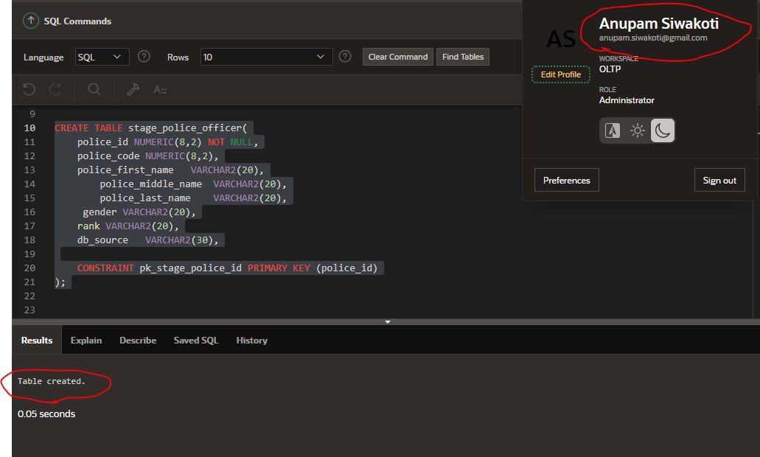

**Create sequence**

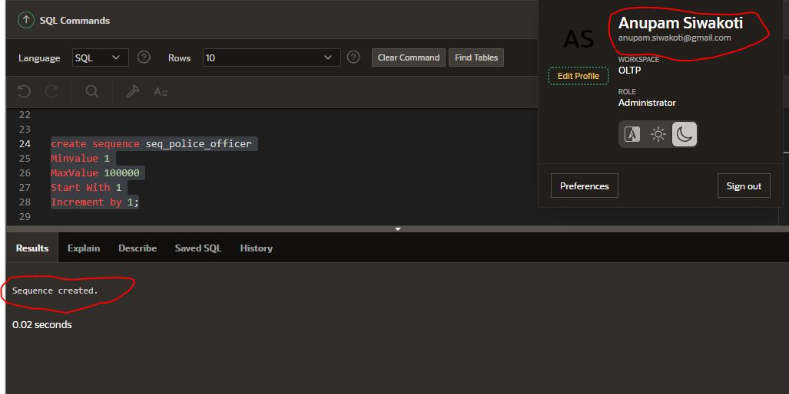

**Create trigger**

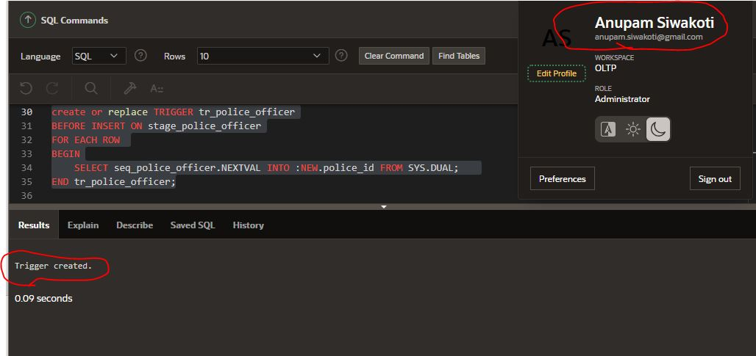

**Create procedure**

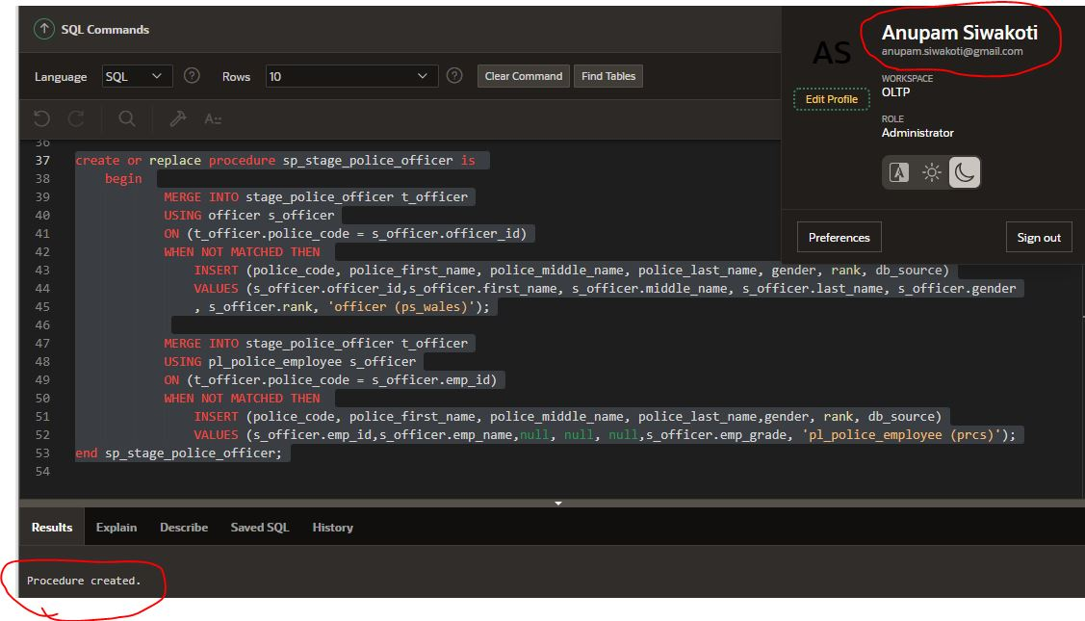

We loaded all the required data from our databases to our stage table, now next process is to separate clean and bad data.

## Separate clean and bad data from stage table

When inserting data into stage table we didn’t validate any data, we just inserted whatever is there in given databases. Data in any database cannot be hundred percent pure, there will be some of ambiguity present in it for example, people may forget to give first name of a person, sometimes they can give data from future etc. All this kind of errors will affect our BI reports, so we must purify as much as we can before loading this data in our dimension and fact table.

We will decompose our stage crime table into two tables (bad_data_crime and clean_data_crime). Decomposing two table means separating data into tables that fits its nature. We can see the example in diagram below

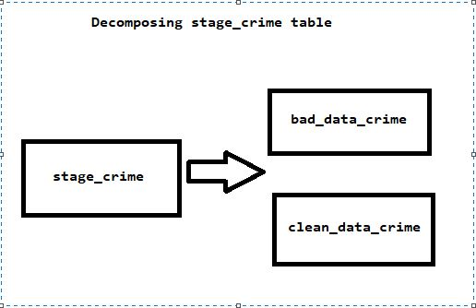

Fig: table decomposition

This process is necessary because when we separate data into different tables, then we can work on bad table separately to make it clean. Also decomposing table means in clean data primary key of record that is pure is the same primary key from stage crime and the record with bad data will have the primary key of bad data from stage crime.

**Create clean_data_crime table**

**CREATE TABLE clean_data_crime(**

**clean_crime_id NUMERIC(8,2) NOT NULL,**

**crime_code NUMERIC(8,2),**

**crime_name VARCHAR2(20),**

**status VARCHAR2(20),**

**reported_date DATE,**

**closed_date DATE,**

**police_officer_id NUMERIC(8,2),**

**location_id NUMERIC(8,2),**

**table_source VARCHAR2(30),**

**CONSTRAINT pk__clean_crime_id PRIMARY KEY (clean_crime_id)**

**);**

**Create bad_data_crime table**

**CREATE TABLE bad_data_crime(**

**bad_crime_id NUMERIC(8,2) NOT NULL,**

**crime_code NUMERIC(8,2),**

**crime_name VARCHAR2(20),**

**status VARCHAR2(20),**

**reported_date DATE,**

**closed_date DATE,**

**police_officer_id NUMERIC(8,2),**

**location_id NUMERIC(8,2),**

**table_source VARCHAR2(30),**

**CONSTRAINT pk__bad_crime_id PRIMARY KEY (bad_crime_id)**

**);**

**Procedure to separate clean and bad table**

**CREATE OR REPLACE PROCEDURE sp_seperate_clean_and_bad_data_crime AS**

**lv_crime_id NUMERIC(8,2); lv_crime_code NUMERIC(8,2);**

**lv_crime_name VARCHAR2(20); lv_status VARCHAR2(20);**

**lv_reported_date DATE; lv_closed_date DATE;**

**lv_police_officer_id NUMERIC(8,2); location_id NUMERIC(8,2);**

**db_source VARCHAR2(20);**

**BEGIN**

**DECLARE**

**CURSOR check_clean_data_crime IS SELECT * FROM stage_crime;**

**BEGIN**

**DELETE FROM bad_data_crime;**

**DELETE FROM clean_data_crime;**

**OPEN check_clean_data_crime;**

**LOOP**

**FETCH check_clean_data_crime INTO lv_crime_id, lv_crime_code, lv_crime_name, lv_status, lv_reported_date, lv_closed_date, lv_police_officer_id, location_id, db_source;**

**EXIT WHEN check_clean_data_crime %notfound;**

**IF lv_crime_name IS NOT NULL AND lv_police_officer_id IS NOT NULL THEN**

**IF lv_status = 'CLOSED' AND lv_reported_date IS NOT NULL AND lv_closed_date IS NOT NULL AND TO_DATE( lv_reported_date, 'mm/dd/yyyy') <= TO_DATE( lv_closed_date, 'mm/dd/yyyy') THEN**

**INSERT INTO clean_data_crime VALUES (lv_crime_id, lv_crime_code, lv_crime_name, lv_status, lv_reported_date, lv_closed_date, lv_police_officer_id, location_id, db_source);**

**ELSIF lv_status = 'OPEN' OR lv_status = 'ESCALATE' AND lv_closed_date IS NULL AND lv_reported_date IS NOT NULL THEN**

**INSERT INTO clean_data_crime VALUES (lv_crime_id, lv_crime_code, lv_crime_name, lv_status, lv_reported_date, lv_closed_date, lv_police_officer_id, location_id, db_source);**

**ELSE**

**INSERT INTO bad_data_crime VALUES (lv_crime_id, lv_crime_code, lv_crime_name, lv_status, lv_reported_date, lv_closed_date, lv_police_officer_id, location_id, db_source);**

**END IF;**

**ELSE**

**INSERT INTO bad_data_crime VALUES (lv_crime_id, lv_crime_code, lv_crime_name, lv_status, lv_reported_date, lv_closed_date, lv_police_officer_id, location_id, db_source);**

**END IF;**

**END LOOP;**

**CLOSE check_clean_data_crime;**

**END check_clean_data_crime;**

**END sp_seperate_clean_and_bad_data_crime;**

## Screen shots for separating clean and bad data from crime

**Create clean_data_crime**

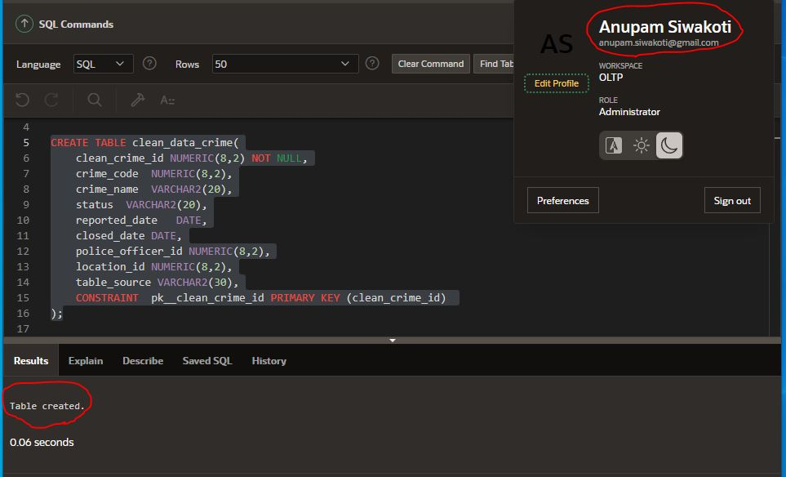

**Create bad_data_crime**

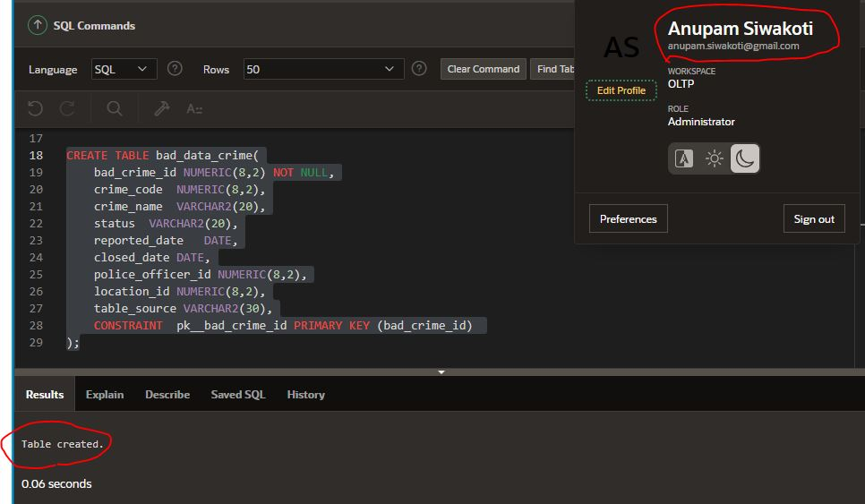

**Procedure for separating clean and bad data for crime**

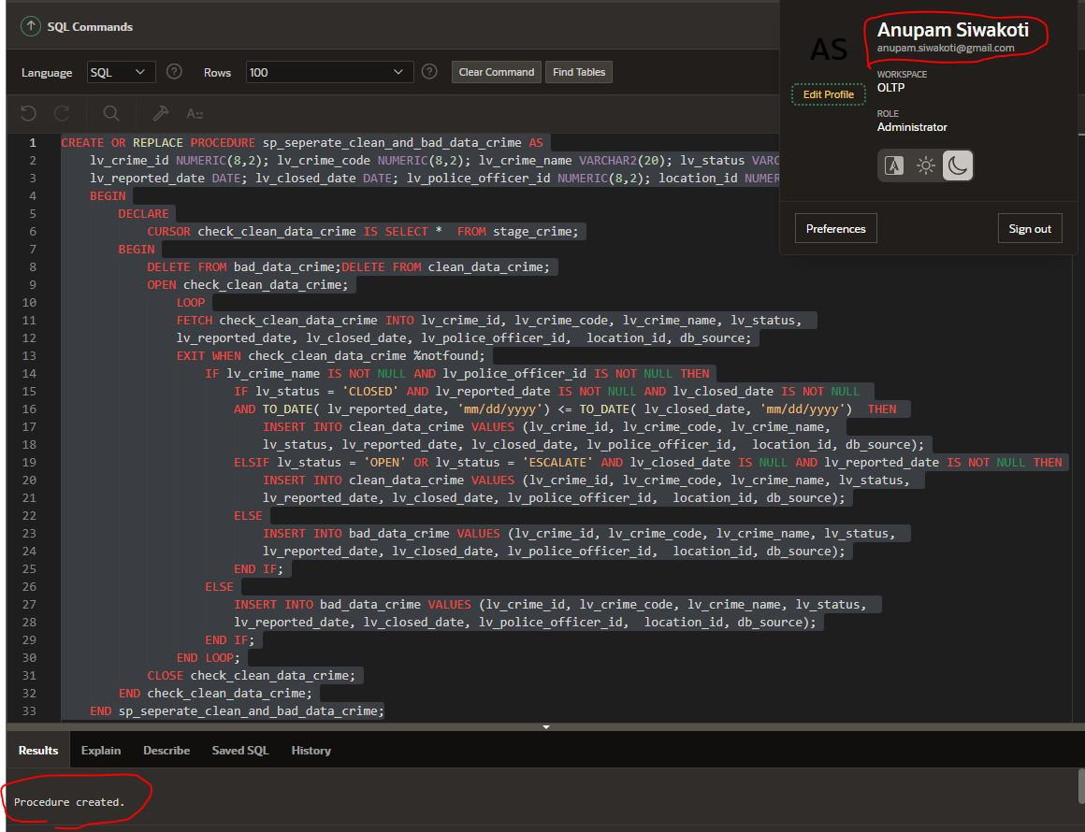

Similarly, I decomposed stage location to bad_data_location and clean_data_location. There was much data provided in the database system so while staging location table I didn’t find any invalid data, so I created bad data. Data that I inserted in stage_location are,

* INSERT INTO stage_location VALUES (22, 23, ‘’, 4, prcs);
* INSERT INTO stage_location VALUES (21,22, ‘’,Null, prcs);
* INSERT INTO stage_location VALUES (21, 40, '', 4, '');
* INSERT INTO stage_location VALUES (41, 30, 'swansea', null, '');

**clean_data_location**

**CREATE TABLE clean_data_location(**

**clean_location_id NUMERIC(8,2) NOT NULL,**

**location_code NUMERIC(8,2),**

**location_name VARCHAR2(20),**

**region_id NUMERIC(8,2),**

**db_source VARCHAR2(30),**

**CONSTRAINT pk_clean_location_id PRIMARY KEY (clean_location_id)**

**);**

**bad_data_location**

**CREATE OR REPLACE PROCEDURE sp_seperate_clean_and_bad_data_location AS**

**lv_location_id NUMERIC(8,2); lv_location_code NUMERIC(8,2);**

**lv_location_name VARCHAR2(20);lv_region_id NUMERIC(8,2);db_source VARCHAR2(20);**

**BEGIN**

**DECLARE**

**CURSOR check_clean_data_location IS SELECT * FROM stage_location;**

**BEGIN**

**DELETE FROM bad_data_location;**

**DELETE FROM clean_data_location;**

**OPEN check_clean_data_location;**

**LOOP**

**FETCH check_clean_data_location INTO lv_location_id, lv_location_code, lv_location_name, lv_region_id, db_source;**

**EXIT WHEN check_clean_data_location %notfound;**

**IF lv_location_name IS NOT NULL AND lv_region_id IS NOT NULL THEN**

**INSERT INTO clean_data_location VALUES (lv_location_id, lv_location_code, lv_location_name, lv_region_id, db_source);**

**ELSE**

**INSERT INTO bad_data_location VALUES (lv_location_id, lv_location_code, lv_location_name, lv_region_id, db_source);**

**END IF;**

**END LOOP;**

**CLOSE check_clean_data_location;**

**END check_clean_data_location;**

**END sp_seperate_clean_and_bad_data_location;**

**CREATE TABLE bad_data_location(**

**bad_location_id NUMERIC(8,2) NOT NULL,**

**location_code NUMERIC(8,2),**

**location_name VARCHAR2(20),**

**region_id NUMERIC(8,2),**

**db_source VARCHAR2(30),**

**CONSTRAINT pk_bad_location_id PRIMARY KEY (bad_location_id));**

**procedure to separate clean and bad data for location**

## Screen shots for separating clean and bad data from crime

**clean_data_location**

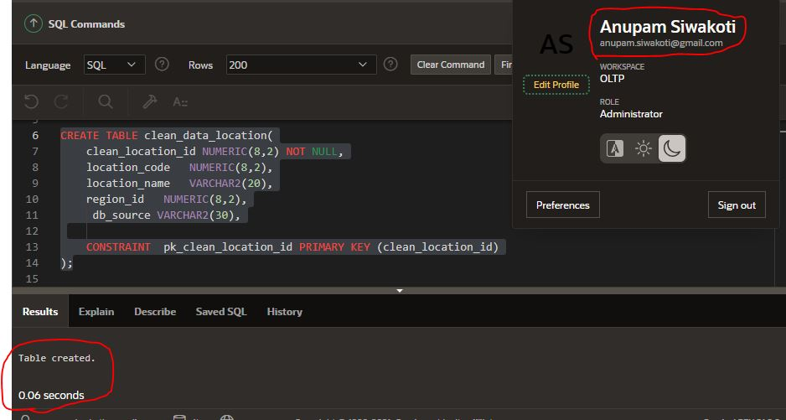

**bad_data_location**

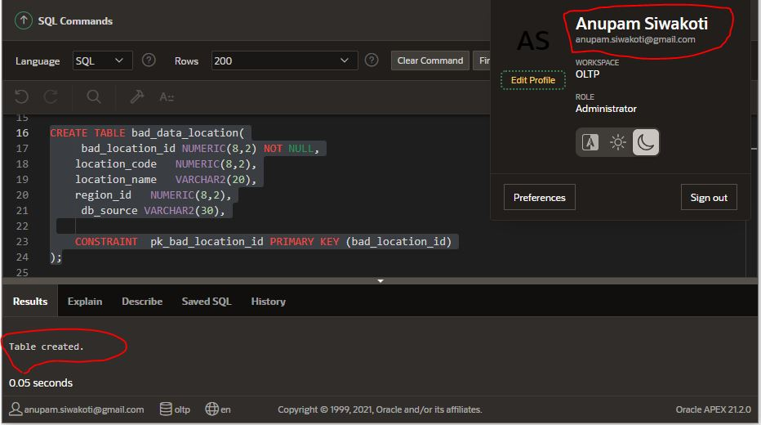

**Procedure for separating data in bad and clean table**

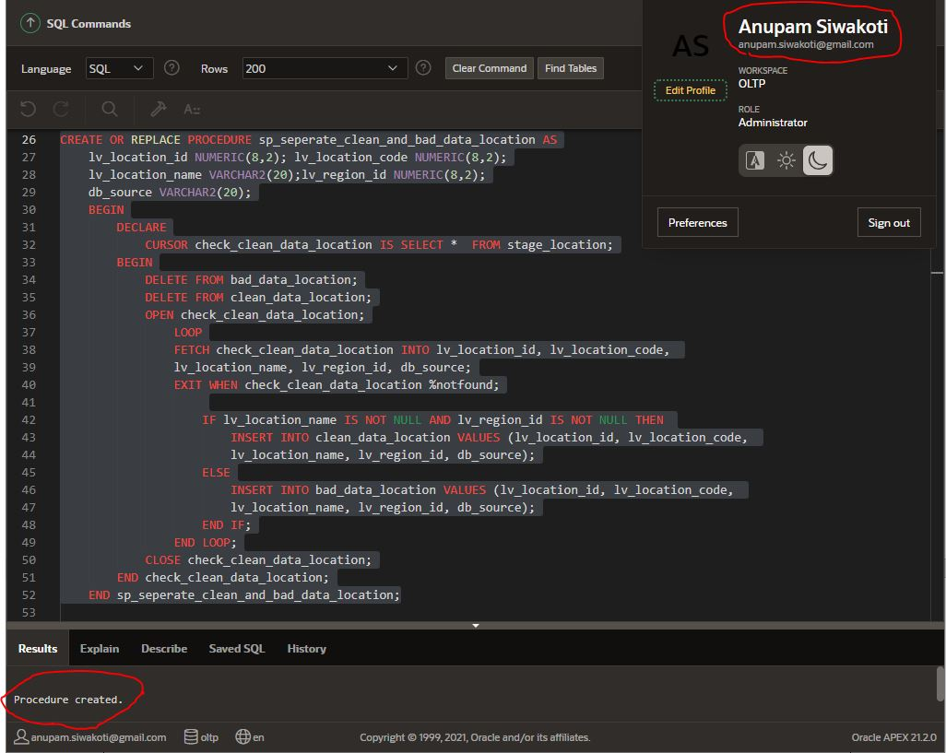

We do the same process for stage_police_officer, we create two tables clean_data_police and bad_data_police.

**Clean_data_police**

**CREATE TABLE clean_data_police(**

**clean_police_id NUMERIC(8,2) NOT NULL,**

**police_code NUMERIC(8,2),**

**police_first_name VARCHAR2(20),**

**police_middle_name VARCHAR2(20),**

**police_last_name VARCHAR2(20),**

**gender VARCHAR2(20),**

**rank NUMERIC(8,2),**

**db_source VARCHAR2(30),**

**CONSTRAINT pk_clean_police_id PRIMARY KEY (clean_police_id));**

**Bad_data_police**

**CREATE TABLE bad_data_police(**

**bad_police_id NUMERIC(8,2) NOT NULL,**

**police_code NUMERIC(8,2),**

**police_first_name VARCHAR2(20),**

**police_middle_name VARCHAR2(20),**

**police_last_name VARCHAR2(20),**

**gender VARCHAR2(20),**

**rank NUMERIC(8,2),**

**db_source VARCHAR2(30),**

**CONSTRAINT pk_bad_police_id PRIMARY KEY (bad_police_id));**

I couldn’t find any bad data from stage_police_officer so inserted some bad data to complete all the process of ETL. I inserted bad data in officer table of ps_wales database system

* INSERT INTO officer VALUES(16, '','','','10/11/2000','Female','Investigation', 10);
* INSERT INTO officer VALUES(17, '','','siwakoti','10/11/2001','male','', 1);
* INSERT INTO officer VALUES(18, '@sureh!','','','10/11/1999','male','law enforcement', 10);
* INSERT INTO officer VALUES(19, '@911Ramesh!','','','10/11/1999','male','law enforcement', 10);

**sp_seperate_clean_and_bad_data_police** procedure checks if officer table has a record with no police name, or if there are any special character in any record then it filters it out and add in bad_data_crime

**Procedure for separating data into bad and good table**

**CREATE OR REPLACE PROCEDURE sp_seperate_clean_and_bad_data_police AS**

**lv_police_id NUMERIC(8,2);**

**lv_police_code NUMERIC(8,2);**

**lv_police_f_name VARCHAR2(30);**

**lv_police_m_name VARCHAR2(30);**

**lv_police_l_name VARCHAR2(30);**

**lv_gender VARCHAR2(30);**

**lv_rank NUMERIC(8,2);**

**db_source VARCHAR2(30);**

**BEGIN**

**DECLARE**

**CURSOR check_clean_data_police IS SELECT * FROM stage_police_officer;**

**BEGIN**

**DELETE FROM bad_data_police;**

**DELETE FROM clean_data_police;**

**OPEN check_clean_data_police;**

**LOOP**

**FETCH check_clean_data_police INTO lv_police_id, lv_police_code, lv_police_f_name, lv_police_m_name, lv_police_l_name, lv_gender, lv_rank, db_source;**

**EXIT WHEN check_clean_data_police %notfound;**

**IF lv_police_f_name IS NOT NULL AND**

**REGEXP_LIKE (REGEXP_REPLACE(lv_police_f_name, '\s'), '^[a-zA-Z]+$') THEN**

**INSERT INTO clean_data_police VALUES (lv_police_id, lv_police_code, lv_police_f_name,**

**lv_police_m_name, lv_police_l_name, lv_gender, lv_rank, db_source);**

**ELSE**

**INSERT INTO bad_data_police VALUES (lv_police_id, lv_police_code,**

**lv_police_f_name, lv_police_m_name, lv_police_l_name, lv_gender, lv_rank, db_source);**

**END IF;**

**END LOOP;**

**CLOSE check_clean_data_police;**

**END check_clean_data_police;**

**END sp_seperate_clean_and_bad_data_police;**

## Screen shots for separating clean and bad data from police

**Clean_data_police**

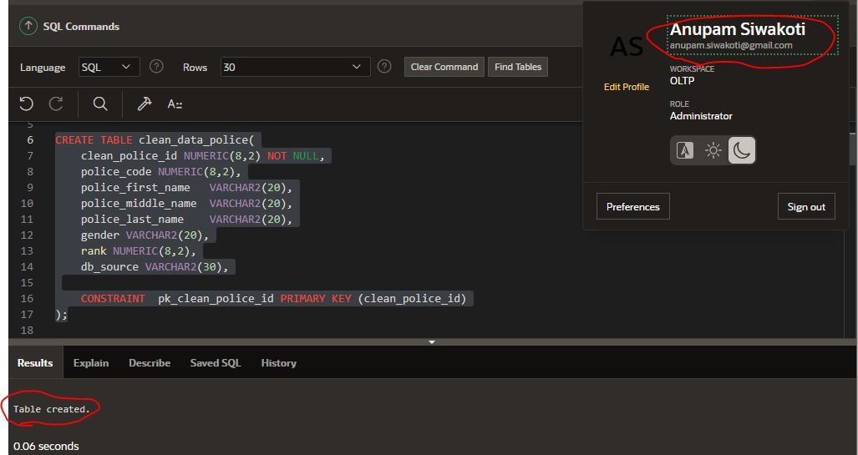

**Bad_data_police**

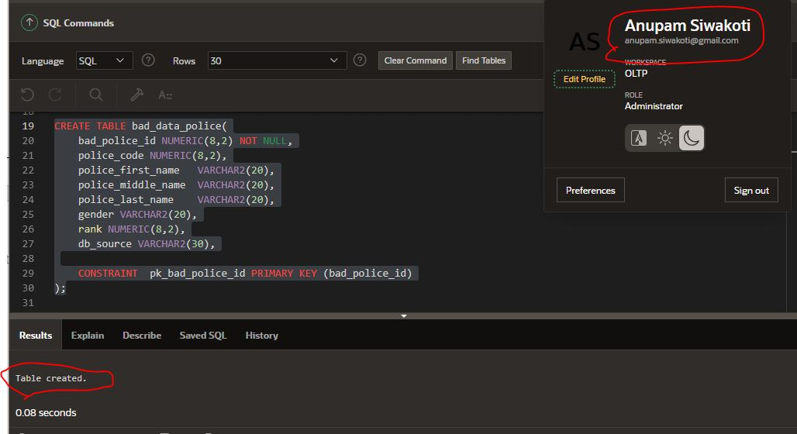

**sp_seperate_clean_and_bad_data_police**

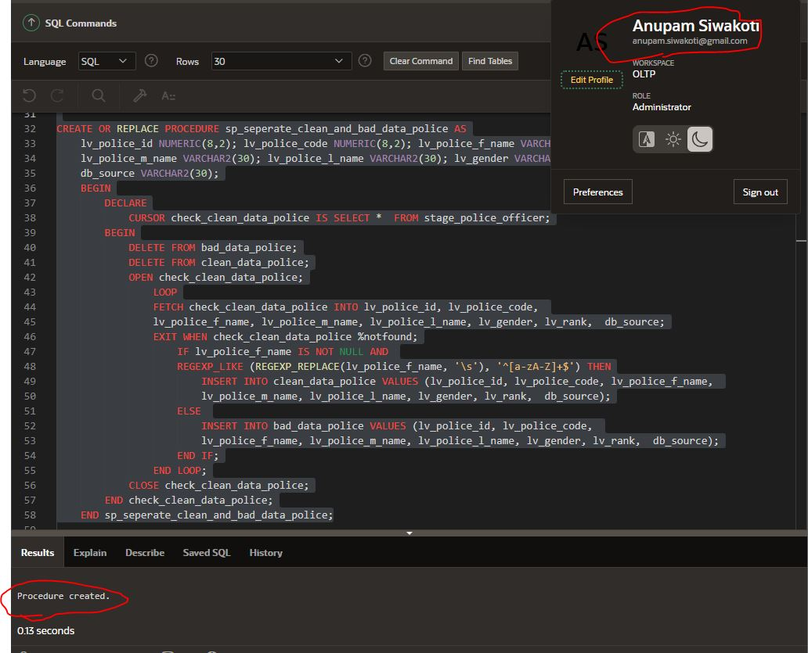

## Recleaning data from bad table

Now that we separated clean and bad table for our respective dimension models, lets re-clean the data in bad table so that we can include all our data for analyzing data. To re-clean the data, we need to create a procedure where we will write our re-cleaning logic. Our bad_data_crime contains row that has following errors

* closed date is lesser than reported date.
* crime name is not provided
* police officer is not allocated
* crime date is not provided for closed crime

**sp_reclean_crime**

**CREATE OR REPLACE PROCEDURE sp_reclean_crime AS**

**lv_bad_crime_id NUMERIC(8,2); lv_crime_code NUMERIC(8,2);**

**lv_crime_name VARCHAR2(20);lv_status VARCHAR2(20);**

**lv_reported_date DATE; lv_closed_date DATE;**

**lv_police_officer_id NUMERIC(8,2); location_id NUMERIC(8,2);**

**db_source VARCHAR2(20);**

**BEGIN**

**DECLARE**

**CURSOR clean_bad_data_crime IS SELECT * FROM bad_data_crime;**

**BEGIN**

**OPEN clean_bad_data_crime;**

**LOOP**

**FETCH clean_bad_data_crime INTO lv_bad_crime_id, lv_crime_code, lv_crime_name, lv_status, lv_reported_date, lv_closed_date, lv_police_officer_id, location_id, db_source;**

**EXIT WHEN clean_bad_data_crime %notfound;**

**IF lv_crime_name IS NULL THEN**

**lv_crime_name := 'UNDEFINED';**

**ELSIF lv_closed_date <= lv_reported_date THEN**

**lv_closed_date := sysdate;**

**ElSIF lv_police_officer_id IS NULL THEN**

**lv_police_officer_id:= NULL;**

**ELSIF lv_status='CLOSED' AND lv_closed_date IS NULL THEN**

**lv_closed_date:=sysdate;**

**ELSE**

**lv_crime_name:=lv_crime_name;**

**END IF;**

**INSERT INTO clean_data_crime VALUES (lv_bad_crime_id, lv_crime_code, lv_crime_name, lv_status, lv_reported_date, lv_closed_date, lv_police_officer_id, location_id, db_source);**

**END LOOP;**

**CLOSE clean_bad_data_crime;**

**END clean_bad_data_crime;**

**END sp_reclean_crime;**

**screen shot of sp_reclean_crime**

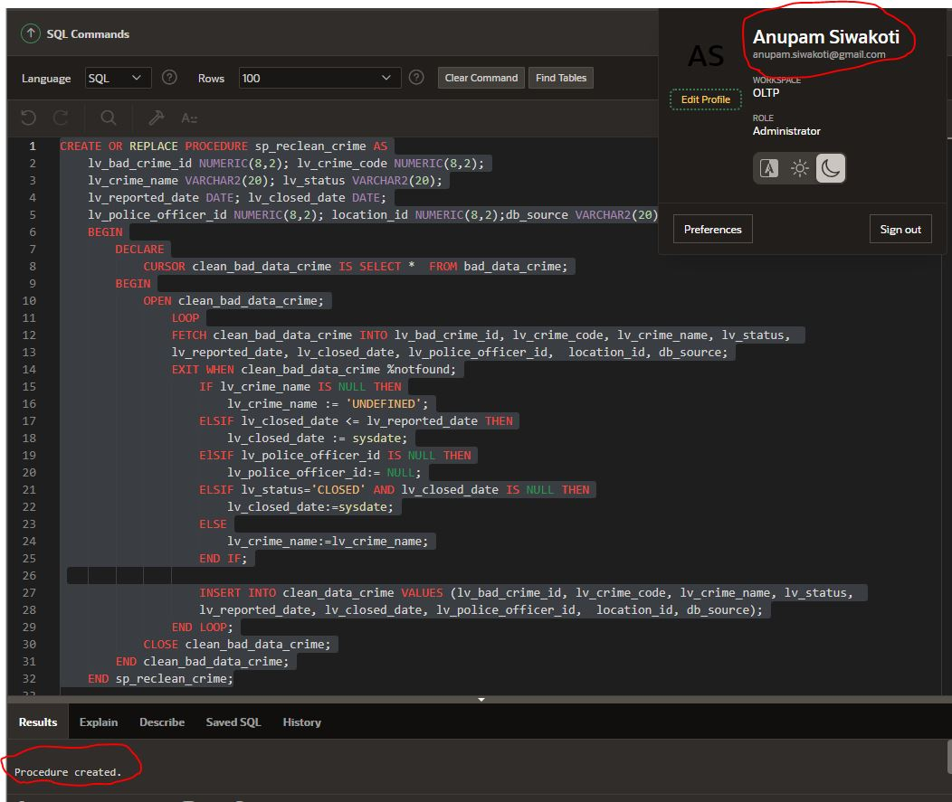

## Re-clean bad data from bad_data_location

**reclean_location**

**CREATE OR REPLACE PROCEDURE sp_reclean_location AS**

**lv_bad_location_id NUMERIC(8,2);**

**lv_location_code NUMERIC(8,2);**

**lv_location_name VARCHAR2(20);**

**lv_region_id NUMERIC(8,2);**

**db_source VARCHAR2(20);**

**BEGIN**

**DECLARE**

**CURSOR clean_bad_data_location IS SELECT * FROM bad_data_location;**

**BEGIN**

**OPEN clean_bad_data_location ;**

**LOOP**

**FETCH clean_bad_data_location INTO lv_bad_location_id, lv_location_code, lv_location_name, lv_region_id, db_source;**

**EXIT WHEN clean_bad_data_location %notfound;**

**IF lv_location_name IS NULL THEN**

**lv_location_name:= 'UNDEFINED';**

**ELSIF lv_region_id IS NULL THEN**

**lv_region_id := NULL;**

**ELSE**

**lv_location_name:=lv_location_name;**

**END IF;**

**INSERT INTO clean_data_location VALUES (lv_bad_location_id, lv_location_code,**

**lv_location_name, lv_region_id, db_source);**

**END LOOP;**

**CLOSE clean_bad_data_location ;**

**END clean_bad_data_location ;**

**END sp_reclean_location;**

**screen shot of sp_reclean_crime**

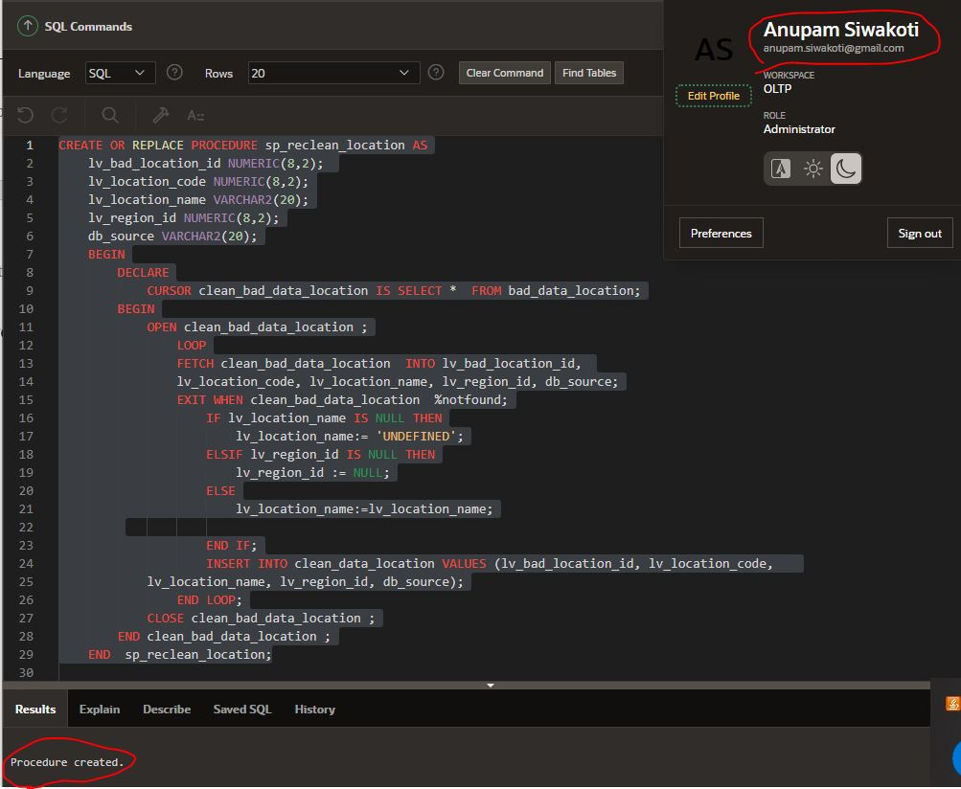

Similarly, we reclean data from bad_data_police, Our bad_data_police contains row that has following errors

* officer name is not provided
* Officer name contains special characters and numbers.

## Re-clean bad data from bad_data_police

**reclean_police**

**CREATE OR REPLACE PROCEDURE sp_reclean_police AS**

**lv_police_id NUMERIC(8,2);**

**lv_police_code NUMERIC(8,2);**

**lv_police_f_name VARCHAR2(30);**

**lv_police_m_name VARCHAR2(30);**

**lv_police_l_name VARCHAR2(30);**

**lv_gender VARCHAR2(30);**

**lv_rank NUMERIC(8,2);db_source VARCHAR2(30);**

**BEGIN**

**DECLARE**

**CURSOR clean_bad_data_police IS SELECT * FROM bad_data_police;**

**BEGIN**

**OPEN clean_bad_data_police ;**

**LOOP**

**FETCH clean_bad_data_police INTO lv_police_id, lv_police_code, lv_police_f_name, lv_police_m_name, lv_police_l_name, lv_gender, lv_rank, db_source;**

**EXIT WHEN clean_bad_data_police %notfound;**

**IF lv_police_f_name IS NULL THEN**

**lv_police_f_name:= 'UNDEFINED';**

**ELSIF lv_police_f_name IS NOT NULL AND NOT REGEXP_LIKE (REGEXP_REPLACE(lv_police_f_name, '\s'), '^[a-zA-Z]+$') THEN**

**lv_police_f_name:= 'UNDEFINED';**

**END IF;**

**INSERT INTO clean_data_police VALUES (lv_police_id, lv_police_code, lv_police_f_name, lv_police_m_name, lv_police_l_name, lv_gender, lv_rank, db_source);**

**END LOOP;**

**CLOSE clean_bad_data_police ;**

**END clean_bad_data_police ;**

**END sp_reclean_police;**

**screen shot of sp_reclean_police**

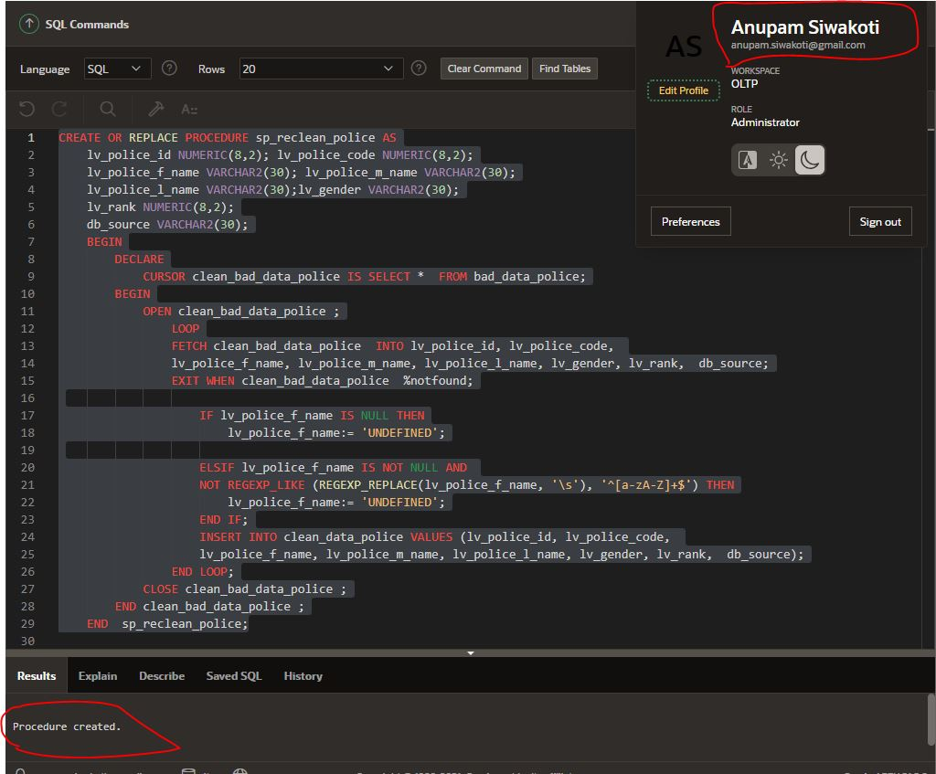

With this we extracted data from two different database system, analyzed those data, separated clean and bad data, recleaned those bad data and now we are ready for transferring this data to transfer table. After transferring data from clean table, we will load our data into our dimension model and fact table which will make our data mart ready for generating reports.

## Transferring data from clean tables to transfer tables

Tables

**Transfer crime table**

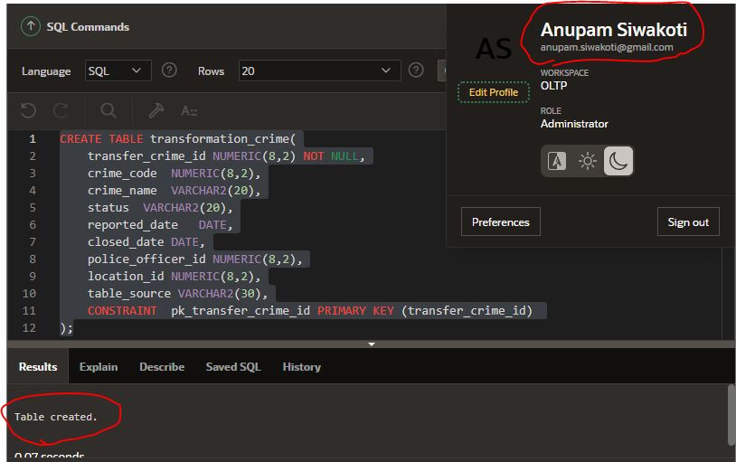

**Transfer location table**

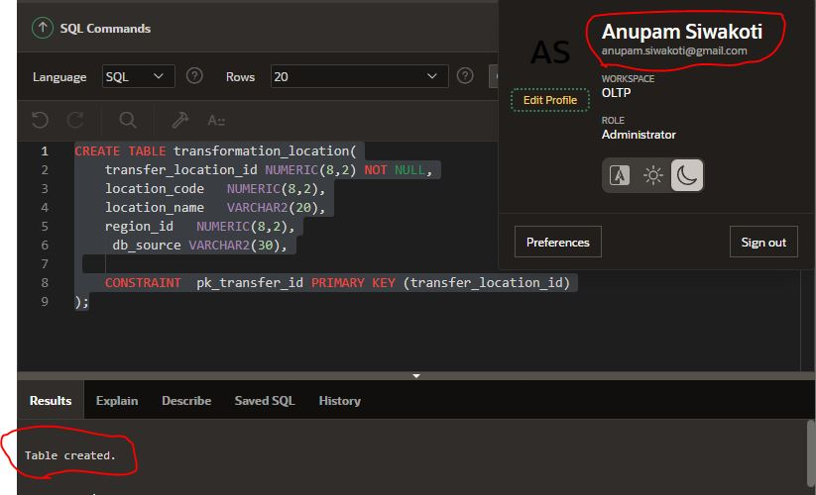

**Transfer police table**

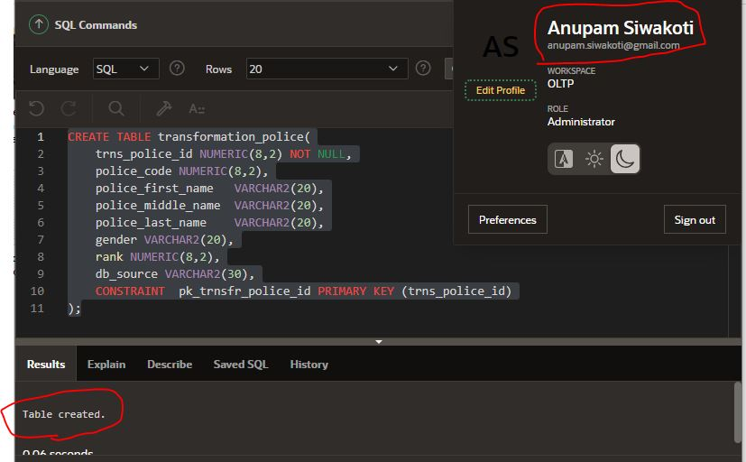

## Screen shots for data transfer from crime, location, and police

**Transfer Crime**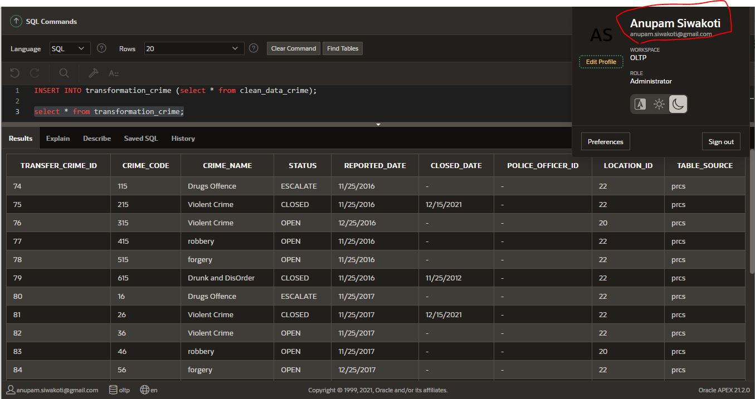

**Transfer location**

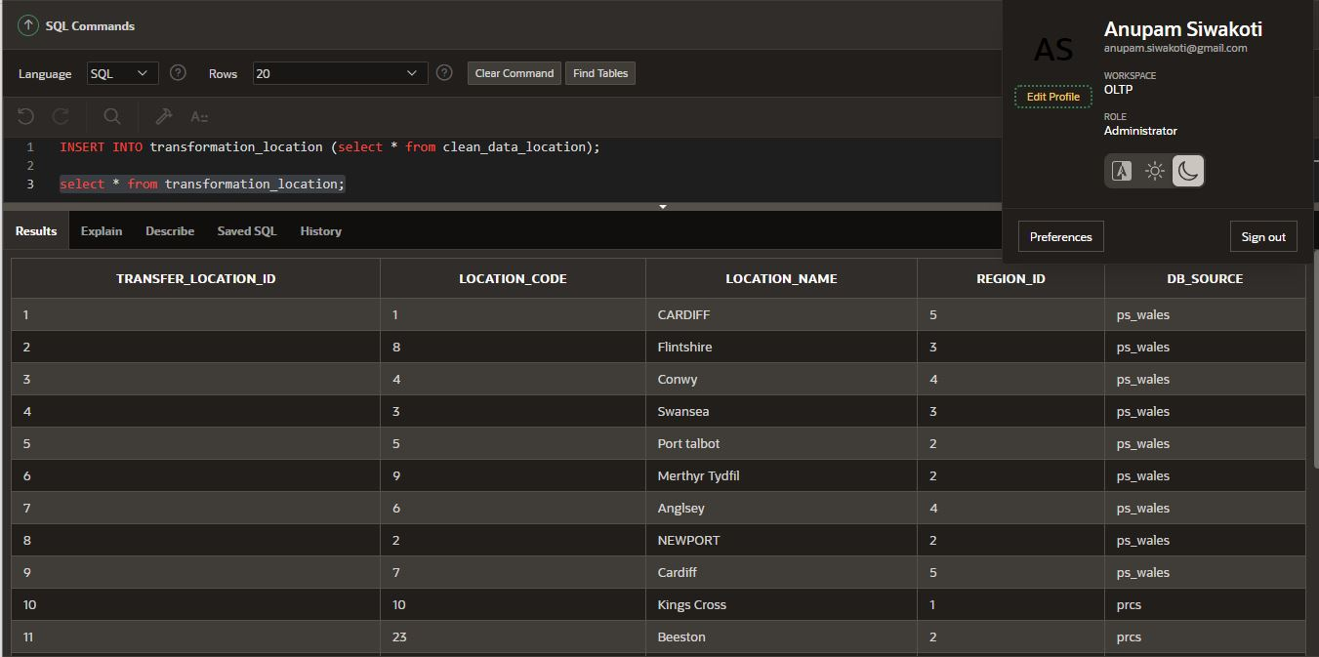

**Transfer Police**

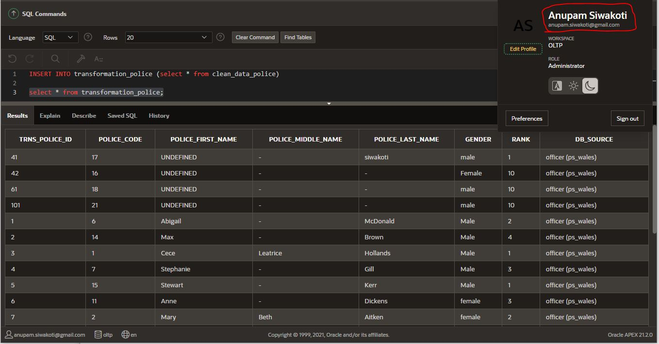

## Loading data from transformation tables to Dimension tables

Finally, we have transferred clean data, now our data is ready to be loaded in our dimension tables. Let’s load all the date in dim_time table, to transfer date related data we first separate day, month and year from reported_date and closed_date column of transformation_crime table and stores that date if it is not present in dim_time table.

**Sp_load_time_dim**

**create or replace procedure sp_load_time_dim AS**

**lv_reported_date DATE; lv_closed_date DATE;**

**lv_day_dest VARCHAR2(10); lv_month_dest VARCHAR2(10);**

**lv_year_dest VARCHAR2(10); lv_row_exists NUMERIC(8,2);**

**cursor cursor_from_source is**

**select reported_date, closed_date from transformation_crime;**

**begin**

**open cursor_from_source;**

**loop**

**fetch cursor_from_source into lv_reported_date, lv_closed_date;**

**exit when cursor_from_source%notfound;**

**lv_year_dest := to_char(lv_reported_date, 'yyyy');**

**lv_month_dest := to_char(lv_reported_date, 'mm');**

**lv_day_dest := to_char(lv_reported_date, 'dd');**

**select COUNT(*) INTO lv_row_exists FROM DIM_TIME WHERE day = lv_day_dest AND**

**month = lv_month_dest AND year = lv_year_dest;**

**IF lv_row_exists = 0 THEN**

**INSERT INTO dim_time VALUES ( seq_dim_time.NEXTVAL, to_char(lv_reported_date, 'dd'), to_char(lv_reported_date, 'mm'), to_char(lv_reported_date, 'yyyy'));**

**END IF;**

**IF lv_closed_date IS NOT NULL THEN**

**lv_year_dest := to_char(lv_closed_Date, 'yyyy');**

**lv_month_dest := to_char(lv_closed_date, 'mm');**

**lv_day_dest := to_char(lv_closed_date, 'dd');**

**select COUNT(*) INTO lv_row_exists FROM DIM_TIME WHERE day = lv_day_dest AND**

**month = lv_month_dest AND year = lv_year_dest;**

**IF lv_row_exists = 0 THEN**

**INSERT INTO dim_time VALUES ( seq_dim_time.NEXTVAL, to_char(lv_closed_date, 'dd'), to_char(lv_closed_date, 'mm'), to_char(lv_closed_date, 'yyyy'));**

**END IF;**

**END IF;**

**end loop;**

**close cursor_from_source;**

**end sp_load_time_dim;**

**Screen shot of procedure that loads dim_time**

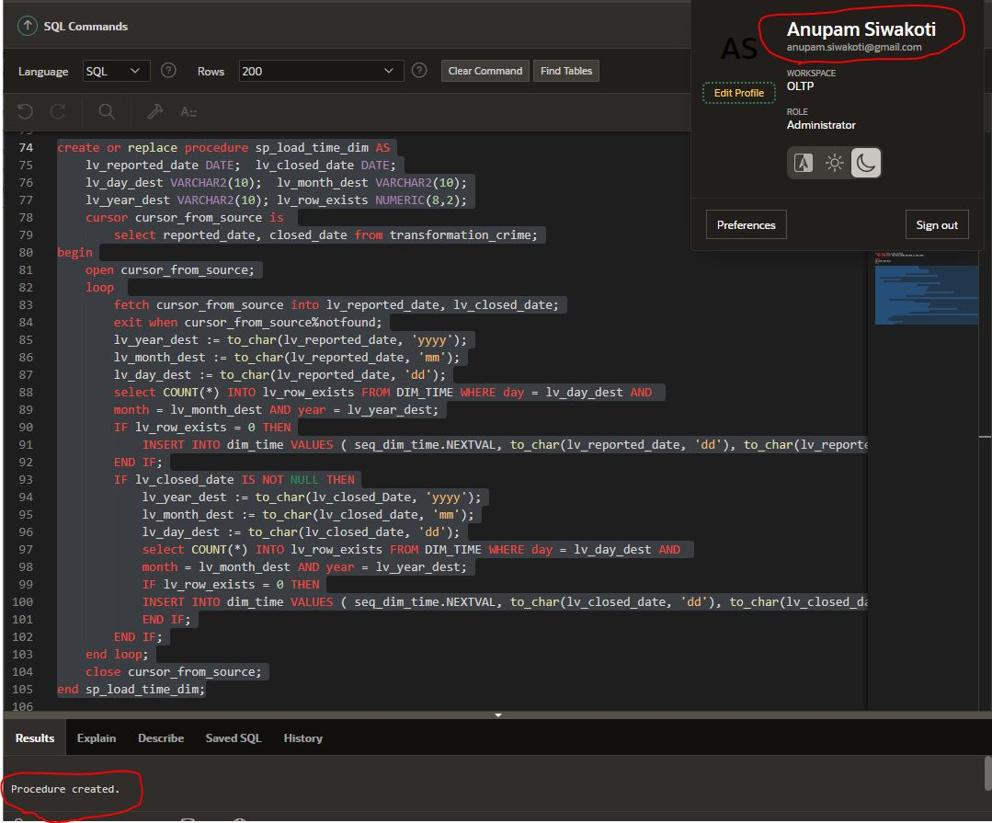

Data from transformation_crime should be loaded in dim_crime, before inserting value we check the availability of reported_date and closed_date. If reported_date or closed_date is present then we insert ‘y’ in reported_date_flag and closed_date_flag.

**Sp_load_crime_dim**

**CREATE OR REPLACE PROCEDURE sp_load_crime_dim AS**

**lv_crime_name VARCHAR2(50);**

**lv_status VARCHAR2(10);**

**lv_reported_date DATE;**

**lv_closed_date DATE;**

**lv_crime_code NUMERIC(8,2);**

**lv_row_exists NUMERIC(8,2);**

**lv_transfer_id NUMERIC(8,2);**

**CURSOR cursor_from_source IS**

**SELECT reported_date, closed_date , crime_code, crime_name, status, transfer_crime_id**

**FROM transformation_crime;**

**BEGIN**

**OPEN cursor_from_source;**

**LOOP**

**FETCH cursor_from_source into lv_reported_date, lv_closed_date, lv_crime_code, lv_crime_name, lv_status, lv_transfer_id;**

**EXIT WHEN cursor_from_source%NOTFOUND;**

**SELECT COUNT(*) INTO lv_row_exists FROM DIM_CRIME WHERE crime_code = lv_crime_code**

**AND status = lv_status AND crime_name = lv_crime_name AND crime_id = lv_transfer_id;**

**IF lv_row_exists = 0 AND lv_reported_date IS NOT NULL AND lv_closed_date IS NOT NULL THEN**

**INSERT INTO dim_crime VALUES (lv_transfer_id, lv_crime_name, lv_status, 'y', 'y', lv_crime_code );**

**ELSIF lv_row_exists = 0 AND lv_reported_date IS NOT NULL AND lv_closed_date IS NULL THEN**

**INSERT INTO dim_crime VALUES (lv_transfer_id, lv_crime_name, lv_status, 'y', 'n', lv_crime_code );**

**ELSE**

**EXIT;**

**END IF;**

**END LOOP;**

**CLOSE cursor_from_source;**

**END sp_load_crime_dim;**

**Screen shot of procedure that loads into dim_time**

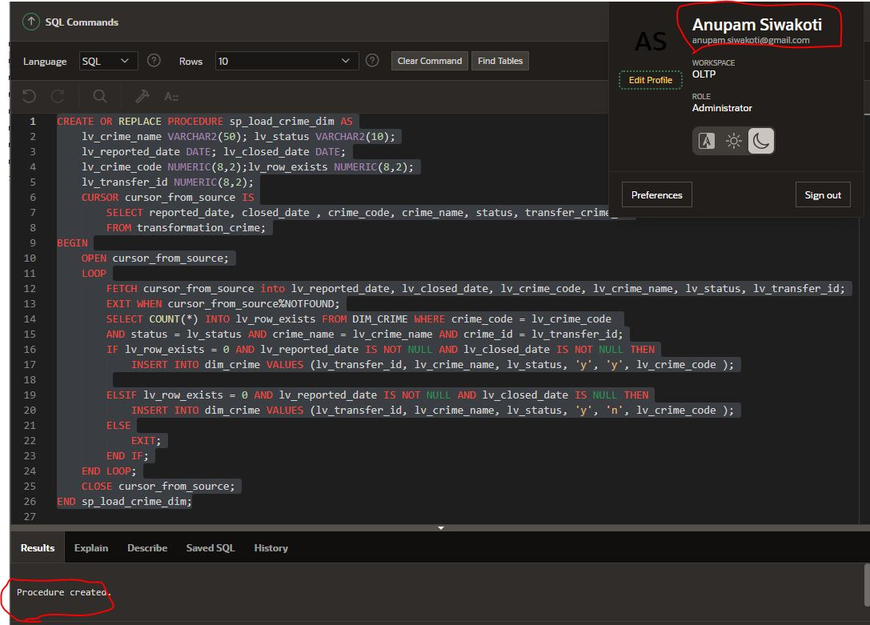

While loading data from transformation_police we merge first_name, middle_name and last_name and save it into dim_police_officer

**Sp_load_police_dim**

**CREATE OR REPLACE PROCEDURE sp_load_police_dim AS**

**lv_first_name VARCHAR2(40); lv_middle_name VARCHAR2(40); lv_last_name VARCHAR2(40);**

**lv_police_code NUMERIC(8,2); lv_gender VARCHAR2(10); lv_rank NUMERIC(8,2);**

**lv_full_name VARCHAR2(100); lv_row_exists NUMERIC(8,2);**

**CURSOR cursor_from_source IS**

**SELECT police_code, police_first_name , police_middle_name, police_last_name, gender, rank**

**FROM transformation_police;**

**BEGIN**

**OPEN cursor_from_source;**

**LOOP**

**FETCH cursor_from_source into lv_police_code, lv_first_name, lv_middle_name, lv_last_name, lv_gender, lv_rank;**

**EXIT WHEN cursor_from_source%NOTFOUND;**

**if lv_middle_name IS NOT NULL AND lv_last_name IS NOT NULL THEN**

**lv_full_name := lv_first_name || ' ' || lv_middle_name || ' ' || lv_last_name;**

**ELSIF lv_middle_name IS NULL AND lv_last_name IS NOT NULL THEN**

**lv_full_name := lv_first_name || ' ' || lv_last_name;**

**ELSE**

**lv_full_name := lv_first_name;**

**END IF;**

**SELECT COUNT(*) INTO lv_row_exists FROM DIM_POLICE_OFFICER WHERE officer_code = lv_police_code AND gender = lv_gender AND fullname = lv_full_name;**

**IF lv_row_exists = 0 THEN**

**INSERT INTO dim_police_officer VALUES (seq_dim_police.NEXTVAL, lv_full_name, lv_gender, lv_rank, lv_police_code);**

**END IF;**

**END LOOP;**

**CLOSE cursor_from_source;**

**END sp_load_police_dim;**

**Screen shot of procedure that loads into dim_time**

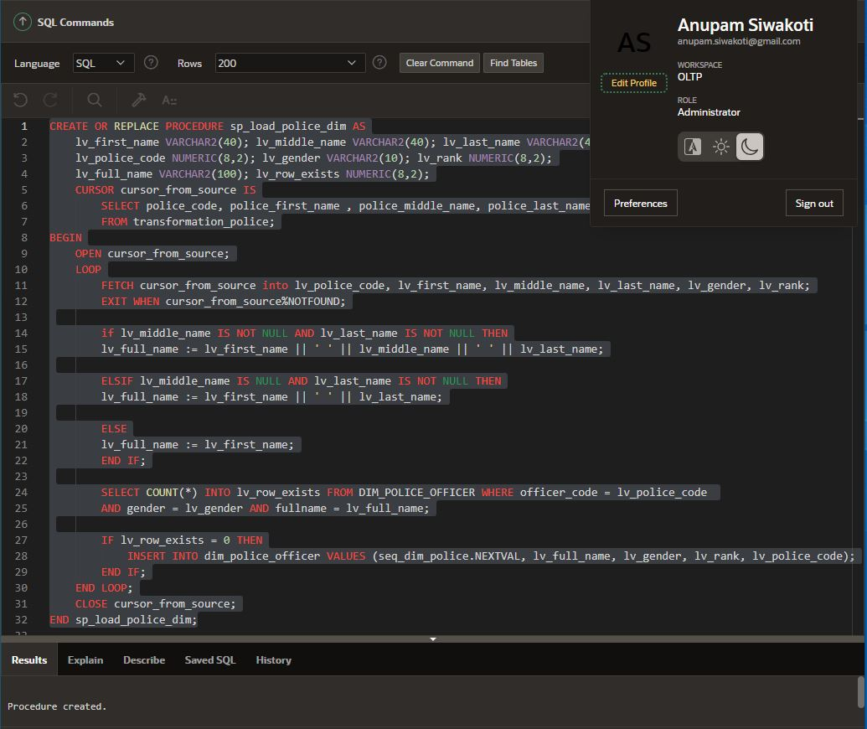

While loading into dim_location, we use region_if from transformation_location to look for the region from their respective database. We extract street_name from location table of ps_wales database. Since, we don’t have street_name is pcrs we save null in those record.

**Sp_load_location_dim**

**CREATE OR REPLACE PROCEDURE sp_load_location_dim AS**

**lv_location_name VARCHAR2(40); lv_region_name VARCHAR2(40);**

**lv_street_name VARCHAR2(40); lv_location_code NUMERIC(8,2);**

**lv_region_id VARCHAR2(10); lv_db_source VARCHAR2(10);**

**lv_row_exists NUMERIC(8,2);**

**CURSOR cursor_from_source IS**

**SELECT location_code, location_name ,region_id, db_source FROM transformation_location;**

**BEGIN**

**OPEN cursor_from_source;**

**LOOP**

**FETCH cursor_from_source into lv_location_code, lv_location_name, lv_region_id, lv_db_source;**

**EXIT WHEN cursor_from_source%NOTFOUND;**

**IF lv_db_source = 'ps_wales' AND lv_region_id IS NOT NULL THEN**

**SELECT region_name INTO lv_region_name FROM region WHERE region_id = lv_region_id;**

**SELECT street_name INTO lv_street_name FROM location WHERE location_id = lv_location_code;**

**ELSIF lv_db_source = 'prcs' AND lv_region_id IS NOT NULL THEN**

**SELECT area_name INTO lv_region_name FROM pl_area WHERE area_id = lv_region_id;**

**lv_street_name := '';**

**ELSE**

**lv_region_name := ''; lv_street_name := '';**

**END IF;**

**SELECT COUNT(*) INTO lv_row_exists FROM DIM_LOCATION WHERE location_code = lv_location_code**

**AND region_name = lv_region_name;**

**IF lv_row_exists = 0 THEN**

**INSERT INTO dim_location VALUES(seq_dim_location.NEXTVAL, lv_region_name, lv_location_name,**

**lv_street_name, lv_location_code);**

**END IF;**

**END LOOP;**

**CLOSE cursor_from_source;**

**END sp_load_location_dim;**

**Screen shot of procedure that loads into dim_location**

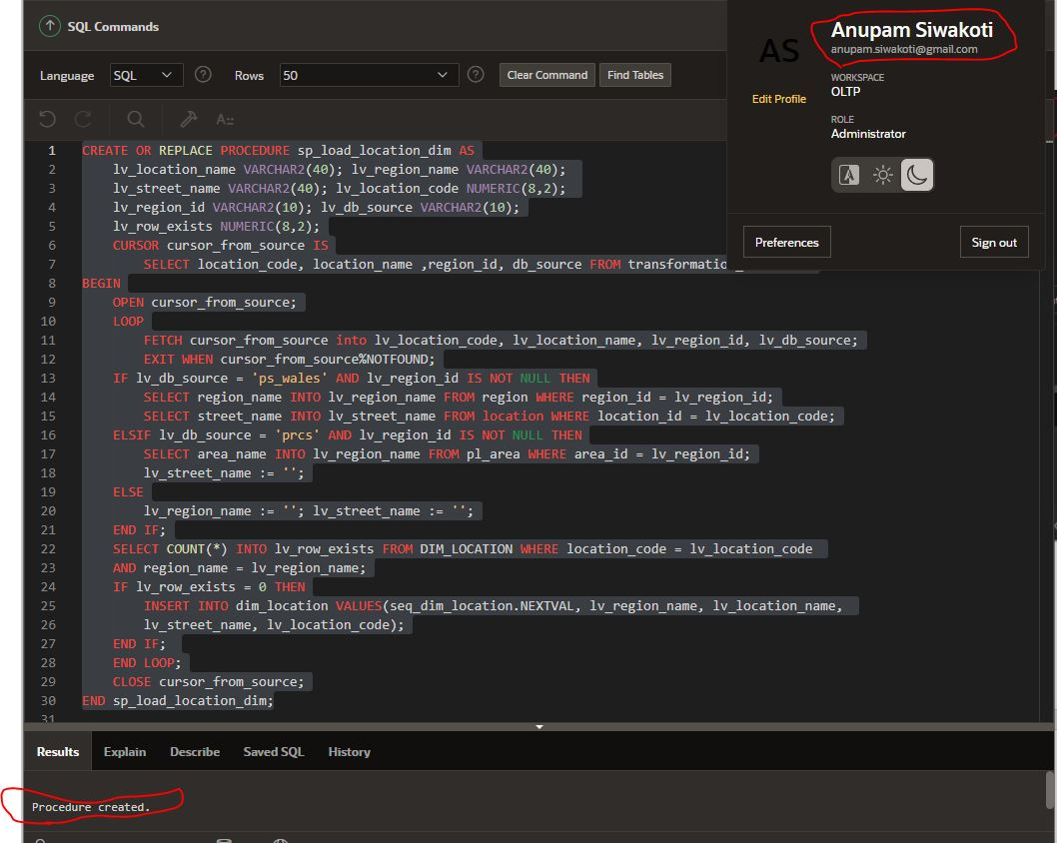

**Sp_load_fact_crime_related**

CREATE OR REPLACE PROCEDURE sp_load_crime_related_fact AS

lv_crime_name VARCHAR2(50); lv_status VARCHAR2(10); lv_reported_date DATE; lv_closed_date DATE; lv_crime_code NUMERIC(8,2);

lv_row_exists NUMERIC(8,2); lv_police_id NUMERIC(8,1); lv_location_id NUMERIC(8,1); lv_source VARCHAR2(10); lv_dim_time_id NUMERIC(8,2); lv_dim_crime_id NUMERIC(8,2);

lv_dim_location_id NUMERIC(8,2); lv_dim_officer_id NUMERIC(8,2); lv_total_crime NUMERIC(8,2); lv_crime_id NUMERIC(8,2); lv_count NUMERIC(8,2) := 0 ;

CURSOR cursor_from_source IS SELECT reported_date, closed_date , crime_code, crime_name, status, police_officer_id, location_id, table_source, TRANSFER_CRIME_ID FROM transformation_crime;

BEGIN

OPEN cursor_from_source; LOOP

FETCH cursor_from_source into lv_reported_date, lv_closed_date, lv_crime_code, lv_crime_name, lv_status, lv_police_id, lv_location_id, lv_source, lv_crime_id;

EXIT WHEN cursor_from_source%NOTFOUND;

SELECT time_id into lv_dim_time_id from dim_time where day = to_char(lv_reported_date, 'dd')

AND month = to_char(lv_reported_date, 'mm') AND year = to_char(lv_reported_date,'yyyy');

SELECT location_id INTO lv_dim_location_id FROM DIM_LOCATION WHERE location_code = lv_location_id;

IF lv_police_id IS NOT NULL THEN

SELECT officer_id INTO lv_dim_officer_id FROM DIM_POLICE_OFFICER WHERE officer_code = lv_police_id;

SELECT COUNT(*) INTO lv_row_exists FROM FACT_CRIME_RELATED WHERE crime_id = lv_crime_id AND location_id = lv_dim_location_id AND time_id = lv_dim_time_id

AND officer_id = lv_dim_officer_id;

IF lv_row_exists = 0 THEN

SELECT COUNT(*) INTO lv_total_crime FROM transformation_crime WHERE crime_name = lv_crime_name AND police_officer_id = lv_police_id AND reported_date = lv_reported_date

AND location_id = lv_location_id;

INSERT INTO FACT_CRIME_RELATED VALUES (lv_crime_id, lv_dim_location_id, lv_dim_officer_id, seq_fact_crime_related.NEXTVAL, lv_dim_time_id, lv_total_crime);

END IF;

ELSE

SELECT COUNT(*) INTO lv_row_exists FROM FACT_CRIME_RELATED WHERE crime_id = lv_crime_id AND location_id = lv_dim_location_id AND time_id = lv_dim_time_id;

IF lv_row_exists = 0 THEN

SELECT COUNT(*) INTO lv_total_crime FROM transformation_crime WHERE crime_name = lv_crime_name AND reported_date = lv_reported_date AND location_id =lv_location_id;

INSERT INTO FACT_CRIME_RELATED VALUES (lv_crime_id, lv_dim_location_id, null, seq_fact_crime_related.NEXTVAL, lv_dim_time_id, lv_total_crime);

END IF;

END IF;

END LOOP;

CLOSE cursor_from_source;

END sp_load_crime_related_fact;

**Screen shot for loading into fact table**

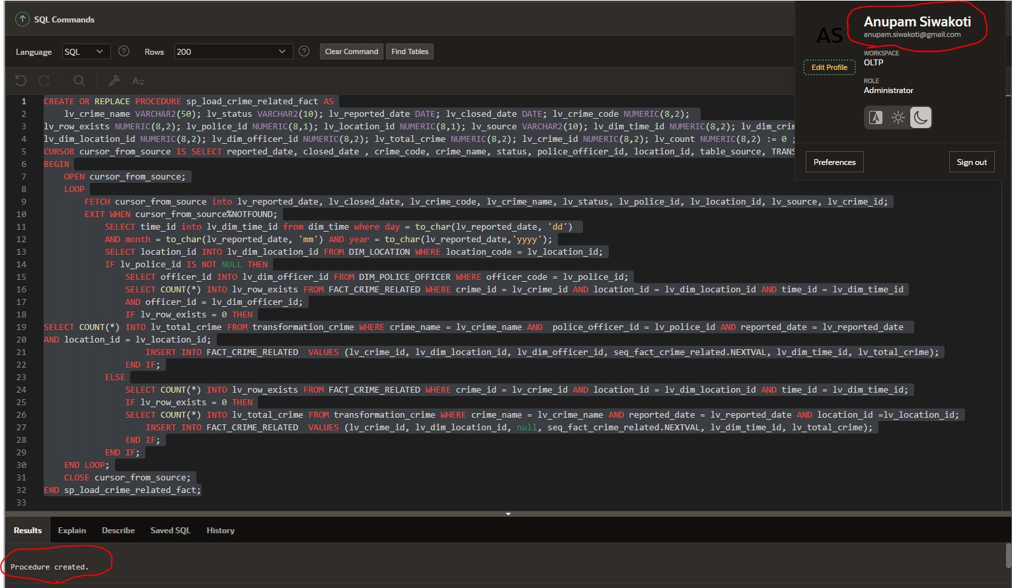

# References

* *Data Warehouse Concepts: Kimball vs. inmon approach*. Astera. (2021, December 7). Retrieved December 22, 2021, from <https://www.astera.com/type/blog/data-warehouse-concepts/>
* Moore, L. (2021, November 2). *What is a Data Mart? definition from searchdatamanagement*. SearchDataManagement. Retrieved December 22, 2021, from https://searchdatamanagement.techtarget.com/definition/data-mart
* *Difference between star schema and Snowflake Schema*. GeeksforGeeks. (2020, July 7). Retrieved December 22, 2021, from https://www.geeksforgeeks.org/difference-between-star-schema-and-snowflake-schema/
* The 7 critical differences between a star schema and a snowflake schema. (n.d.). Retrieved December 22, 2021, from https://www.keboola.com/blog/star-schema-vs-snowflake-schema
* Kimball, R., & Ross, M. (n.d.). *The Data Warehouse Toolkit: The definitive guide to dimensional modeling*.
* The 21st International Computer Science and Engineering Conference 2017. (2017). *2017 21st International Computer Science and Engineering Conference (ICSEC)*. https://doi.org/10.1109/icsec.2017.8443902